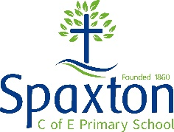 Spaxton proposed new curriculum topics overview from September 2021+
 | Autumn |  | Spring |  | Summer
Year 5&6 - Peregrine
A | Space Race |  | Ancient times |  | Myths & Legends/Ancient Greece
B | Romans |  | Disasters |  | Art through the ages
Year 3&4 - Kingfisher
A | Poverty (everyday people) beyond 1066 |  | Human Body |  | The middle East/Egyptians
B | Europe |  | Saxons v’s Vikings |  | Water/local history
Year R,1&2 – Starlings
A | Minibeasts | Weather | Save the planet | People | Castles | Royalty
B | Making | Celebrations | London | Great fire of London | Other cultures
C | Food | Guy Fawkes | Memories | Outside | Animals | Seaside

