SUBJECT-SPECIFIC CURRICULAR INFORMATION
ENGLISH
English Curriculum Intent
What do we want to develop in our children through English?

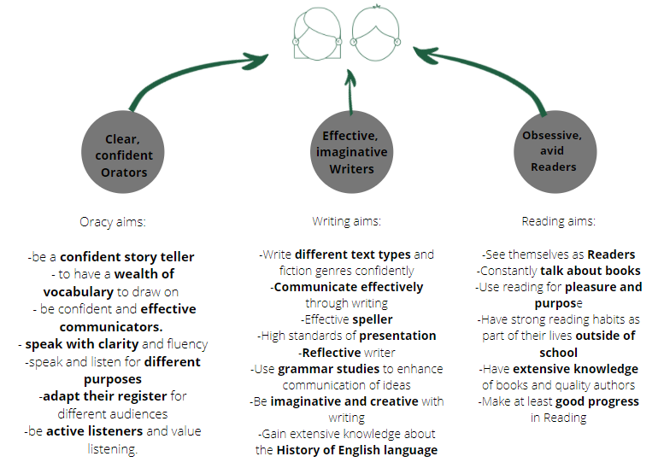
English plays an important role in children's lives and together we want all children to flourish and achieve. The rationale behind this policy is that in order for children to grow as Orators, Writers and Readers, they need to gain a passion for literature and gain extensive knowledge of books so that they have purposes for writing, a love for reading and develop crucial oracy skills. We want these habits to be with them for the rest of their lives. The knowledge gained from certain books is also culturally rich and we see this as being crucial in delivering social equality in our community.
Our English Curriculum is rooted in research and the decision to teach through high quality models of language and literature is for two reasons:
-John Hattie sets out oral language programmes as having a high effect size on progress and achievement
-Children who do better in writing and academic work are usually avid readers.

How is the English Curriculum implemented?
Our two main approaches to the teaching of English is Talk for Writing and Power of Reading. We use Letters and Sounds Phonics and the National Curriculum Spelling Framework from Year 2 onwards. Our handwriting programme comes from Debbie Hepplewhite Handwriting.
We use whole year group/class Guided Reading sessions to develop understanding of texts to supplement English lessons. Individual Reading is done through a coloured book band system where children progress up through on to Free Reading. Each phase uses Talk for Writing and Power of Reading for their main English lessons in different ways to meet the emerging needs of the children.

SUBSTANTIVE KNOWLEDGE OVERVIEW
A child will gain the following knowledge each year:

Fiction | Different plot structures/ genres | How to entertain | High quality texts/ authors | Reading for pleasure
Non-Fiction | How to inform | How to persuade | How to discuss | Writing for pleasure
Poetry | Poetry Forms | Culturally-rich poetry | Poetry to recite | Word play and experimentation

Example phase overview
English Overview Sep 2021

TRUST  CURRICULUM  Years 5-6 | Term 1 | Term 2 | Term 3 | Term 4 | Term 5 |  | Term 6
Year A | ‘COSMIC’ By Frank Cottrell-Boyce  Fiction: Science Fiction writing  Focus: Character  Plot type: Finding tale  Non-fiction: Persuasion and NCR  Poetry: Grace Nicholls ‘Cosmic Disco’ forms of poetry |  | ‘WOLF BROTHER’ by Michelle Paver  Fiction: Historic fiction  Focus: Setting and suspense  Plot type: Quest/ journey  Non-fiction: Recount and discussion  Poetry: Atmospheric poetry |  | ‘KENSUKE’S KINGDOM’ by Michael Morpurgo  Fiction: Tragic story  Focus: Openings and Endings  Plot type: Losing  Non-fiction: Instructions and Diary writing  Poetry: Reciting poetry
Year B | ‘KRINDLEKRAX’’ by Phillip Ridley  Fiction: Modern Fiction  Plot type: Defeat the Monster  Focus: Description  Non-Fiction x 2: Discussion and NCR  Poetry: Poems for fun |  | ‘FLOODLAND’ By Marcus Sedgwick/ The Time Slip Scarab  Fiction: Thriller  Plot type: Portal  Focus: Settings  Non-Fiction x 2: Explanation and Newspaper  Poetry: Collaborative poetry |  | THE LADY OF SHALOTT by Alfred Tennyson  Non-Fiction: Persuasion  Poetry: Performance Poetry | THE HIGHWAYMAN by Alfred Noyes  Fiction: Adventure story  Non-Fiction: Instructions  Poetry: Performance Poetry

DISCIPLINARY KNOWLEDGE OVERVIEW

Teachers plan from starting points using assessments. The aim is to teach from starting points but teach year-group-specific objectives to achieve age-related expectations. In particular, the application of grammar and punctuation skills to achieve effects (what works in writing) is a major focus of our English lessons.

Teachers conduct assessments throughout the learning process and decide whether to teach content whole class, year-group, or group specific. Expectations, essentials (Every time I write) or Year Group objectives are shared through toolkits or success criteria so standards are achieved.

Example- teachers look for what content to teach next from their assessments, looking for where group work is needed as well as common threads across whole classes.

Y2 Child’s name:
QUALIFIERS: most: the statement is generally met with only occasional errors
many: the statement is met frequently but not yet consistently
some: the skill/ knowledge is starting to be acquired
consistent or fre

KS1 Working towards the expected standard
The pupil can, after discussion with the teacher:
- write sentences that are sequenced to form a short narrative (real or fictional)
- demarcate some sentences with capital letters and full stops
- segment spoken words into phonemes and represent these by graphemes, spelling some words correctly and making phonically-plausible attempts at others
- spell some common exception words
- form lower-case letters in the correct direction, starting and finishing in the right place
- form lower-case letters of the correct size relative to one another in some of their writing
- use spacing between words.

KS1 Working at the expected standard
The pupil can, after discussion with the teacher:
- write simple, coherent narratives about personal experiences and those of others (real or fictional)
- write about real events, recording these simply and clearly
- demarcate most sentences in their writing with capital letters and full stops, and use question marks and exclamation marks correctly when required
- use present and past tense mostly correctly and consistently
- use co-ordination (e.g. or / and / but) and some subordination (e.g. when / if / that / because) to join clauses
- segment spoken words into phonemes and represent these by graphemes, spelling many of these words correctly and making phonically-plausible attempts at others
- spell many common exception words
- form capital letters and digits of the correct size, orientation and relationship to one another and to lower-case letters
- use spacing between words that reflects the size of the letters.
KS1 Working at greater depth within the expected standard
The pupil can, after discussion with the teacher:
- write effectively and coherently for different purposes, drawing on their reading to inform the vocabulary and grammar of their writing
- make simple additions, revisions and proof-reading corrections to their own writing
- use the punctuation taught at key stage 1 mostly correctly
- spell most common exception words
- add suffixes to spell most words correctly in their writing (e.g. –ment, –ness, –ful, –less, –ly)
- use the diagonal and horizontal strokes needed to join some letters.

We have overviews like this for all year groups and have worked alongside Stogursey Primary to create bespoke versions matching the academic rigor of the TAF (Teacher Assessment Framework) and adding further exemplification around Greater Depth in each year group. We have also added in year-by-year content for Grammar, Punctuation and Spelling from the National Curriculum.

ENGLISH TEACHING EXPECTATIONS
A phase-by-phase approach to English
As children progress through the school, their needs change and so this diagram shows approximately the diet of English they get in each phase.

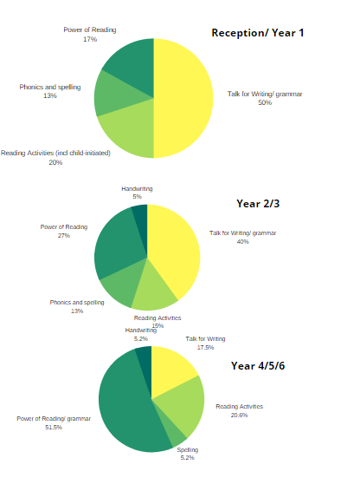
PLANNING ENGLISH
There is no preferred lesson planning format. All that is required is a unit plan to show what has been planned in a unit and this should be displayed somewhere in the classroom.
Mixed-Age Classes
Due to our school's size, most teaching is done in mixed-age classes. This can be a challenge, although not impossible. The vast majority of the time, concepts can be matched up across year groups and the whole class can be taught together.
There are three purposes to English lessons in our school and suggested sources of planning are listed with each purpose.

UNDERSTAND
This will be for the majority of lessons. We use the either, Talk for Writing or Power of Reading teaching sequences to plan these sessions.
PRACTISE
This needs to be built in regularly. There should be regular evidence of practice built into units so that children can consolidate learning.
APPLY
Opportunities must be planned for extended writing and short-burst writing. This is to build stamina. Success Criteria can be co-constructed or given and then children can spend longer writing.
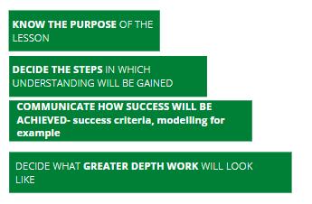
SCAFFOLDING THOSE WHO NEED IT
The expectation is that all children except for those with an exceptional reason (SEND child requiring a separate bespoke curriculum for instance) should be aiming to achieve the same high standards. Some children will find this challenging so here's what could help enable access to the same challenging learning.
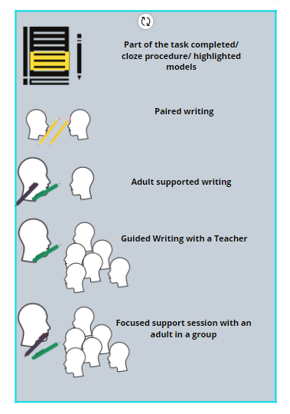
CHILDREN WORKING WITHIN THE EXPECTED STANDARD AT GREATER DEPTH
Teachers should know through writing moderation what is needed to gain greater depth writers. This can be the Talk for Writing list of Greater Depth activities and Bloom’s Taxonomy.
Bloom's Taxonomy
Although many of the ideas below we do in English lessons anyway, try to visualise this in a different way. Visualise how doing one of these items especially (from 'analyse' and below) could be done differently compared to the majority of the class.
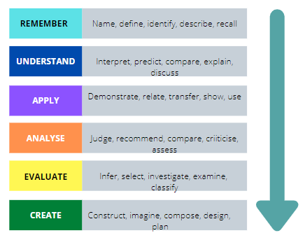
Expectations of work in books
The following has been agreed:
- Children should attempt to apply the learning from handwriting lessons in all books
- Long dates should be in books, underlined starting on the second line
- The same high standards of presentation expected in English books are expected in all books
- All staff should model good handwriting when writing in children’s books
- Sticking in should be neat and straight
- If children are using pens, this should be done neatly
- Children need to take pride in their work.
As with presentation, children should also apply learning from grammar, punctuation and spelling lessons in all books. Sight words should mostly be spelled correctly with a good phonetic attempt at unfamiliar words. Children should be able to access resources in class to be able to succeed at this.

The teacher will know best individuals who have come up short in terms of standards and effort and children are expected as in our behaviour policy to have an opportunity to talk this through with an adult and to have a chance to put it right. Whether this is the next lesson, in the lesson or in own time is down to the teacher.

How do we measure the impact of the English Curriculum?
Teachers assess the substantive knowledge and disciplinary knowledge gained through reading, writing spelling, grammar and punctuation 3 times a year and these judgements are moderated both internally and externally for quality assurance reasons. Teachers assess through benchmarking, reading records, and full standardised tests/ screening checks twice yearly (February and June). Children’s progress and attainment is investigated by Senior Leaders and Trust staff at Pupil Progress Meetings 3 times a year.
English Subject Leader Monitoring investigates 3 times a year:
QET Curriculum Principle | Examples of success | Where will they find this?
Sequenced? | - Is key writing knowledge logically-ordered?  - Are GPS lessons applied in writing lessons?  - Do lessons follow the 3 Is for writing? | - Book scrutiny  - Internal moderation  - Working walls  - Learning walks/ drop ins
Motivating? | - Are children independent?  - Have they taken ownership? | - Pupil voice  - Sparkling starts
Ambitious? | - Is sufficient progress being made in transcriptional skills?  - Are children reading widely and for fun? | - Book scrutiny  - Internal moderation  - Working walls  - Learning walks/ drop ins  - Memory morning  - Data
Responsive? | - Do lessons deviate from the plan?  - Are Guided Writes happening with those who need them? | - Book scrutiny  - Working walls  - Learning walks/ drop ins
Transformative? | - Are children more confident in their English skills?  - Have children gone on to do something in their own time on this? | - Pupil voice  - Fabulous Finish  - Memory morning  - Data

MATHEMATICS

Mathematics Mastery Curriculum Intent
What do we want to develop in our children through Maths?
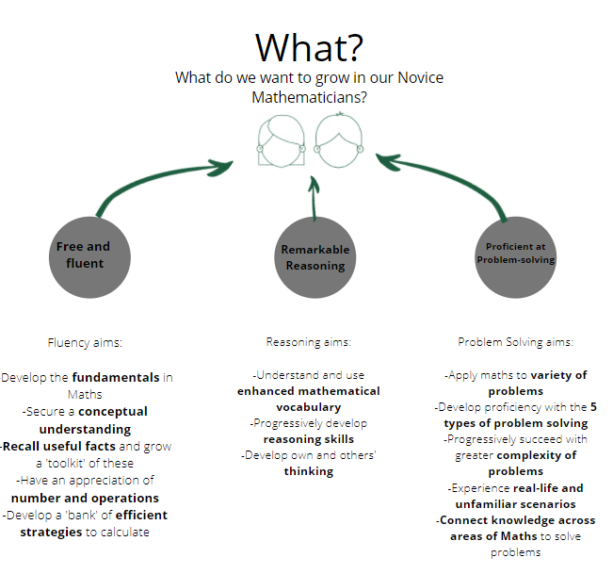
Mastery is our chosen approach. The main difference that stands out with the Mastery approach is that children are taught together to master their own year group's objectives and deepen rather than rush onto the next year's content. The mindset shift for adults is to not label children. All children are capable of learning Maths to a high level. Some children will take longer than others to grasp content and others will grasp content rapidly. This doesn't necessarily make them better Mathematicians.
Mathematics plays an important role in children's lives and in our we want all children to Flourish and achieve together. The rationale behind this policy is that in order for children to progress as Mathematicians, they need to gain a deep understanding of the concepts underpinning Mathematics in order to succeed in the three aims of Fluency, Problem Solving and Reasoning.
Our Maths Curriculum is rooted in research and the decision to teach through Mastery came about as the only approach that aids conceptual understanding, promotes a connectionist approach (Askew et al) and truly develops children's confidence as Mathematicians. Mastery has also been identified in Hatties's meta-analyses of what works as being highly effective.

The scheme of learning we mainly use is White Rose and we believe in their motto-

How is the Maths Curriculum implemented?

We follow the overview from White Rose Maths and do not follow a spiral curriculum. The sequence is well-thought out and the order builds on previous units, encouraging interleaving. The small-steps approach builds on prior learning both from the previous lesson, previous units and previous years. Topics are revisited each year except for year-specific topics. The order of the knowledge to be gained varies per year group. Methods of calculations are taken from our calculation policy.
Fluency, problem solving and reasoning are built into every lesson and tasks reflect this. ‘Rapid graspers’ get an opportunity in every lesson to build a portfolio of greater depth work, growing in complexity and connections through ‘If you finish tasks’. Dojo’s are awarded for levels of success in this greater depth work. Discrete problem-solving lessons are taught through other materials.

Example Overview

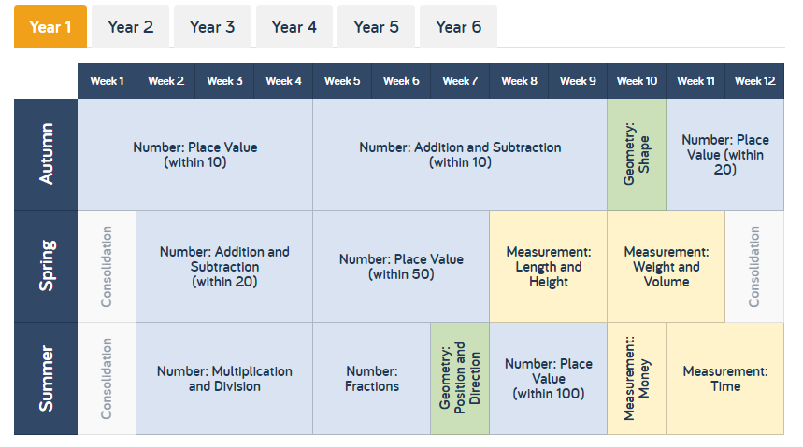

MATHS TEACHING EXPECTATIONS
PLANNING MATHS LESSONS
There is no preferred lesson-planning format. All that is required is a unit plan to show what has been planned in a unit and this should be displayed somewhere in the classroom so that adults and children alike can see the learning journey ahead as well as to track what came before. An example is below.
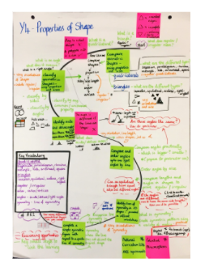
Mixed-Age Classes
Due to our school's size, most teaching is done in mixed-age classes. This can be a challenge, although not impossible. Mixed age planning and overviews are available from White Rose and the vast majority of the time, concepts can be matched up across year groups. and the whole class can be taught together. Here are some options to consider making it work when they don't match.
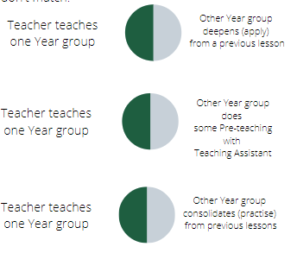
There are three purposes to Maths lessons in our school and suggested sources of planning are listed with each purpose.
UNDERSTAND
This will be for the majority of lessons. We use White Rose to plan lessons to include all 3 aims of Maths but in a structured way. The Premium Resources also set out tasks and include Procedural Variation to aid quicker progress.
PRACTISE
This needs to be built in regularly. There should be regular evidence of practice built into units so that children can consolidate learning.
APPLY
It is important that not just the 'rapid graspers' do this. Each unit needs to have a chance to develop at least one type of problem solving in more depth.
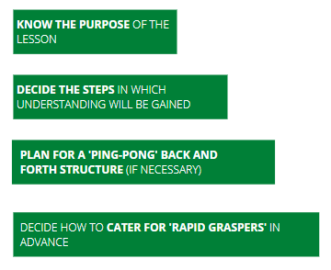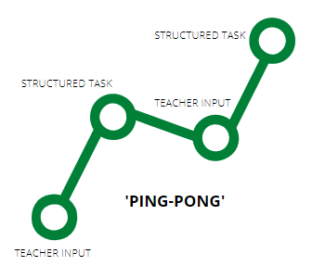
When planning a structured task, it is crucial not to aim for pages and pages of questions. This does not aid understanding. Each structured task should have no more than 5 questions. The aim is for children to 'keep up' not 'catch up'. 'If you finish' questions that are open-ended are key in building resilience in your rapid graspers as well as freeing adults up to support those who need it.
In an 'understand' lesson, structured task 1 should enable the children to 'practise the fundamentals' to understand the concept being taught in the small step. The next structured tasks should enable the children to look at 'what it is also' as well as 'what it is NOT'. Lessons should teach from misconceptions and teachers should know this in advance.
A small step does not equate to one lesson. Most take longer. White Rose shows how children can move their understanding from concrete to pictorial to abstract thinking for each step.
Keeping the class together with self-marking
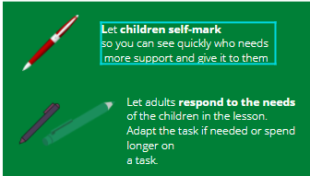
Self-marking in the lesson is an effective way of keeping the class together. Build in an ‘If you finish’ task at the end of a set of questions that stretches the rapid graspers and gives them an opportunity to build a portfolio of greater depth work. Monitor this by awarding gold stars for getting it right, silver for a good go but not quite correct. Either build an open-ended task by reusing a question they have just completed or use the acronym DEPTH to create your own:
Do you agree?
Explicit use of a mistake- give feedback
Probing question
The wrong answer for a fellow finisher
Here’s the answer. What was the question?

How do we measure the impact of the Maths Curriculum?
Teachers assess the substantive knowledge and disciplinary knowledge gained through Maths lessons 3 times a year and these judgements are moderated both internally and externally for quality assurance reasons. Teachers assess through practice quizzes, tables tests, end of unit ‘memory mornings’ and full standardised tests/ screening checks twice yearly (February and June). Children’s progress and attainment is investigated by Senior Leaders and Trust staff at Pupil Progress Meetings 3 times a year.
Maths Subject Leader Monitoring investigates 3 times a year:
QET Curriculum Principle | Examples of success | Where will they find this?
Sequenced? | - Is content ordered in small steps?  - Do lessons have a chance for fluency, problem solving and reasoning? | - Book scrutiny  - Internal moderation  - Working walls  - Learning walks/ drop ins
Motivating? | - Are children independent?  - Have they taken ownership? | - Pupil voice  - Sparkling starts
Ambitious? | - Is sufficient progress being made in fact recall?  - Are children using advanced terminology to aid reasoning? | - Book scrutiny  - Internal moderation  - Working walls  - Learning walks/ drop ins  - Memory morning  - Data
Responsive? | - Do lessons deviate from the plan?  - Are different forms of mastery lessons being used? | - Book scrutiny  - Working walls  - Learning walks/ drop ins
Transformative? | - Do children see themselves as mathematicians?  - Have children gone on to do something in their own time on this? | - Pupil voice  - Fabulous Finish  - Memory morning  - Data

SCIENCE
Science Curriculum Intent
Why is the Science Curriculum important at Spaxton?
At Spaxton, we want our children to be naturally curious about the world around them. Our curriculum has been developed by staff to ensure full coverage of the National Curriculum and to foster a sense of wonder about natural phenomena. We are committed to providing a stimulating, engaging and challenging learning environment. Throughout our school, children are encouraged to develop their substantive knowledge through key topics and their disciplinary knowledge, working scientifically by experiencing the five types of enquiry: observation of changes over time; grouping and classifying; researching; fair testing and pattern seeking. We develop our children’s abilities to behave, think and talk like scientists. We want our children to have a broad vocabulary. Scientific language is to be taught and built upon as topics are revisited in different year groups and across key stages. We intend to provide all children regardless of ethnic origin, gender, class, aptitude or disability with a broad and balanced science curriculum.

How is the Science Curriculum implemented?
We deliver the content in a logical order by phases of the National Curriculum so that the substantive knowledge is delivered in sequence. Children learn to work scientifically using the 5 types of enquiry and these are:
- Pattern Seeking
- Observation of changes over time
- Fair Testing
- Research
- Grouping and classifying
When teachers plan their units, they endeavour to fit in all 5 types of enquiry so that children’s understanding of what it is to be a scientist develops over time. In addition to this, teachers assess the disciplinary knowledge of working scientifically using our progressions. There are four areas of focus across the whole school and these are:
- Asking the question
- Collecting data
- Analysing data and drawing conclusions
- Presenting findings
Teachers assess how on track classes are towards this disciplinary knowledge and then tailor the delivery of the substantive knowledge by focusing on one of these areas each unit. This creates quite a bespoke learning journey each time that meets the scientific needs of each class.
When sequencing the learning journeys, teachers bring these elements together and also consider cross curricular skills such as formal experiment write-ups, peer reviewing and measuring skills so that the knowledge of how other subjects play their role in Science is developed further.

How do we measure the impact of the Science Curriculum?
Science Subject Leader Monitoring investigates over a year:
QET Curriculum Principle | Examples of success | Where will they find this?
Sequenced? | - Is key knowledge logically-ordered?  - Are the 5 types of enquiry happening? | - Book scrutiny  - Internal moderation  - Working walls  - Learning walks/ drop ins
Motivating? | - Are children independent?  - Have they taken ownership? | - Pupil voice  - Sparkling starts
Ambitious? | - Is sufficient progress being made in working scientifically?  - Are children reading widely and for fun about Science? | - Book scrutiny  - Internal moderation  - Working walls  - Learning walks/ drop ins  - Memory morning  - Data
Responsive? | - Do lessons deviate from the plan?  - Are lessons bespoke from what is needed using the ‘Working Scientifically’ assessment of disciplinary knowledge? | - Book scrutiny  - Working walls  - Learning walks/ drop ins
Transformative? | - Are children more confident in their Science knowledge?  - Have children gone on to do something in their own time on this? | - Pupil voice  - Fabulous Finish  - Memory morning  - Data

COMPUTING
Computing Curriculum Intent
Why is the Computing Curriculum important at Spaxton?
In line with the 2014 National Curriculum for Computing, our aim is to provide a high-quality computing education, which equips children to use computational thinking and creativity to understand and change the world. The curriculum will teach children key knowledge about how computers and computer systems work, and how they are designed and programmed. Learners will have the opportunity to gain an understanding of computational systems of all kinds, whether or not they include computers. By the time they leave Spaxton, children will have gained key knowledge and skills in the three main areas of the computing curriculum: computer science (programming and understanding how digital systems work), information and communication technology (using computer systems to store, retrieve and send information) and digital literacy (evaluating digital content and using technology safely and respectfully). The objectives within each strand support the development of learning across the key stages, ensuring a solid grounding for future learning and beyond.

How is the Computing Curriculum implemented?
This is currently planned using the agreed objectives from our schemes of work and delivered either discretely or through the cross-curricular topic.
How do we measure the impact of the Computing Curriculum?
Computing Subject Leader Monitoring investigates over a year:
QET Curriculum Principle | Examples of success | Where will they find this?
Sequenced? | - Is key knowledge logically-ordered?  - Is there a good mix of ICT, Computer Science and Digital Literacy? | - Book scrutiny  - Internal moderation  - Working walls  - Learning walks/ drop ins
Motivating? | - Are children independent?  - Have they taken ownership? | - Pupil voice  - Sparkling starts
Ambitious? | - Is debugging happening?  - Are children reading widely and for fun about computing? | - Book scrutiny  - Internal moderation  - Working walls  - Learning walks/ drop ins  - Memory morning  - Data
Responsive? | - Do lessons deviate from the plan?  - Are lessons connected to the topic? | - Book scrutiny  - Working walls  - Learning walks/ drop ins
Transformative? | - Are children more confident?  - Have children gone on to do something in their own time on this? | - Pupil voice  - Fabulous Finish  - Memory morning  - Data

MODERN FOREIGN LANGUAGE (MFL)

MFL Curriculum Intent
Why is the MFL Curriculum important at Spaxton?

It is our intent at Spaxton to provide all of our children with a high-quality education in Modern Foreign Languages (MFL), which develops their love of learning about other languages and cultures. Our current MFL taught is French, however we strive to provide children with opportunities to experience a range of other languages. It is our intention to ensure that by the end of our children’s primary education, they have acquired an understanding of both spoken and written French, confidence to speak in French with others and know how important other languages can be in their future.

How is the MFL Curriculum implemented?
This is currently planned using the agreed objectives from our schemes of work and delivered either discretely or through the cross-curricular topic.
How do we measure the impact of the MFL Curriculum?
MFL Subject Leader Monitoring investigates over a year:
QET Curriculum Principle | Examples of success | Where will they find this?
Sequenced? | - Is key knowledge logically-ordered?  - Is there a chance for practice and recap during new year group orientation? | - Book scrutiny  - Internal moderation  - Working walls  - Learning walks/ drop ins
Motivating? | - Are children independent?  - Do children enjoy being able to talk a different language? | - Pupil voice  - Sparkling starts
Ambitious? | - Is sufficient progress being made?  - Are children reading widely and for fun about MFL? | - Book scrutiny  - Internal moderation  - Working walls  - Learning walks/ drop ins  - Memory morning  - Data
Responsive? | - Do lessons deviate from the plan?  - Are lessons planned from what is needed using the assessments? | - Book scrutiny  - Working walls  - Learning walks/ drop ins
Transformative? | - Do children want to visit other countries?  - Have children gone on to do something in their own time on this? | - Pupil voice  - Fabulous Finish  - Memory morning  - Data

PHYSICAL EDUCATION (PE)

PE Curriculum Intent
Why is the PE Curriculum important at Spaxton?
Our intent at Spaxton is that our teaching of Physical Education will mould fit, active, and healthy children, who have a positive mindset towards being a team player and taking part in competitive sport.
Our intent for our Physical Education approach is:
- To put Fundamental Movement Skills at the core of our teaching, so that children are confident and competent across a broad range of agility, balance, and coordination skills.
- To teach children the ability to effectively transfer skills across a range of activities and sports.
- To embed the belief that new challenges are opportunities to learn and develop, underpinned by the ability to recognise personal strengths and weaknesses as crucial to personal development.
- To teach children how to plan and how to revise that plan when necessary, seeking advice and accepting critical feedback to make changes.
- To ignite the desire to engage in competition (both against self and against others) and co-operative physical activities, in a range of increasingly challenging situations.
- To embed a culture of collaboration and communication between peers
- To kick start a lifelong positive disposition towards leading a fit, active, and healthy lifestyle.
- To ensure that all children that leave our school can swim competently, confidently, and proficiently over a distance of at least 25 metres.
At Spaxton, pupils are taught how to be fit and healthy, and why this is important. The intent is that the pupils at our school will be able to explain clearly how choices that they make have an impact on their health and wellbeing. The belief behind the school’s approach to Physical Education is that all pupils can become physically confident, and that the school has a duty to provide practice for this across a range of activities and opportunities. Pupils at Spaxton are strongly encouraged to take part in sporting events and competitions, to not only promote a sense of belonging to the school, but to also develop characteristics associated with sport such as patience, persistence and equality. The National Curriculum States that a high- quality Physical Education curriculum should,
“inspire all pupils to succeed and excel in competitive sport and other physically-demanding activities. It should provide opportunities for pupils to become physically confident in a way which supports their health and fitness. Opportunities to compete in sport and other activities build character and help to embed values such as fairness and respect”.
To ensure that pupils develop the right skills at the right time, our Physical Education curriculum is organised into a progression model which breaks the development of a skill, linked to the National Curriculum, in to the required steps needed to be proficient.
How is the PE Curriculum implemented?
This is currently planned using the agreed objectives from our schemes of work and delivered either discretely or through the cross-curricular topic. Inspired Schools PE coaches come and deliver our PE sessions as well as run extra-curricular activities to ensure a greater love of physical development. Cross school competitions are encouraged and the children thrive when representing the school in a variety of physical events.

How do we measure the impact of the PE Curriculum?
PE Subject Leader Monitoring investigates over a year:
QET Curriculum Principle | Examples of success | Where will they find this?
Sequenced? | - Is key knowledge logically-ordered?  - Is there a balance of the fundamental movement skills? | - Internal moderation  - Working walls  - Learning walks/ drop ins
Motivating? | - Are children independent?  - Have they taken ownership? | - Pupil voice  - Sparkling starts
Ambitious? | - Is sufficient progress being made by all children?  - Are children reading widely and for fun about sports? | - Internal moderation  - Working walls  - Learning walks/ drop ins  - Data
Responsive? | - Do lessons deviate from the plan?  - Are lessons planned from what is needed using national curriculum guidance | - Working walls  - Learning walks/ drop ins
Transformative? | - Do children want to compete?  - Have children gone on to do something in their own time on this? | - Pupil voice  - Data

RELIGIOUS EDUCATION (RE)
RE Curriculum Intent

Why is the RE Curriculum important at Spaxton?
As a Church of England School, the Christian faith is the foundation of everything that we do at Spaxton. In all learning and life experiences, we aim to fulfil our school vision. We promote an environment where all children feel known, accepted, and valued as individuals, within a caring community, where our Christian faith affects not only what we teach, but also how we teach.

We believe that it is fundamental for the children to belong to a safe and nurturing community, founded on strong Christian values where children will develop an array of skills, grow in knowledge and character so that they can make their own positive contribution to our global society.

Our aims for all the children in RE are:
- To provoke challenging questions about the ultimate meaning of life, beliefs about God, the nature of reality and morality.
- To develop pupils’ knowledge and understanding of Christianity, other principal world religions, religious traditions and world-views, which offer answers to ultimate questions.
- To encourage pupils to develop their sense of identity and belonging, in order to flourish within communities, as responsible citizens in society and global communities.
- To teach pupils to develop respect for others and their beliefs and helps to challenge prejudice.
- To prompt pupils to consider their responsibilities to themselves and to others, and to explore how they might contribute to their communities and to wider society encouraging empathy, generosity and compassion.

How is the RE Curriculum implemented?

Our whole curriculum is shaped by our school vision, which aims to enable all children to flourish and achieve.
The statement of entitlement lays out that all children will receive a high quality Religious Education that supports them in all aspects of their learning.
“Religious education in a Church school should enable every child to flourish and to live life in all its fullness. (John 10:10). It will help educate for dignity and respect encouraging all to live well together” (Statement of Entitlement)
The statement lays out the details of coverage of the RE curriculum in church schools. We ensure that we fully meet the requirement of the statement of entitlement for Church schools.
Our RE teaching is informed by two different teaching schemes; Understanding Christianity and Oxford Diocesan RE Scheme of work. By using these schemes alongside each other, we are ensuring children are given the opportunity to become religiously literate.
Understanding Christianity is based upon seven core Christian concepts. Children will explore the different concepts in a range of inspiring activities as they move through the school, starting in Foundation Stage and developing a great depth of understanding by the time they reach Year 6.
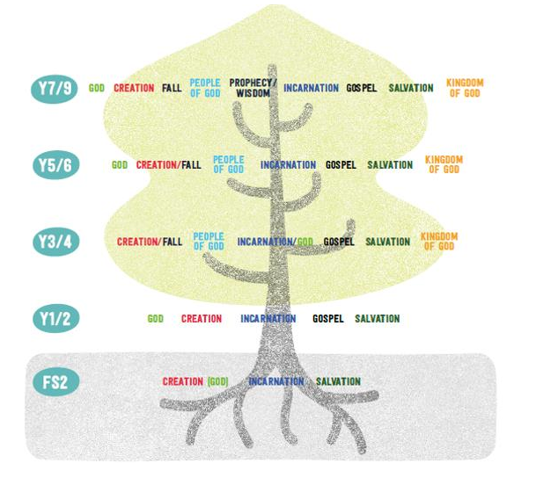
Understanding Christianity believes that not only should children show an understanding of the religious text and teachings but they should also demonstrate a deepened and more thoughtful approach to their learning and how this influences day to day life. Therefore is based upon a three step enquiry model of teaching.

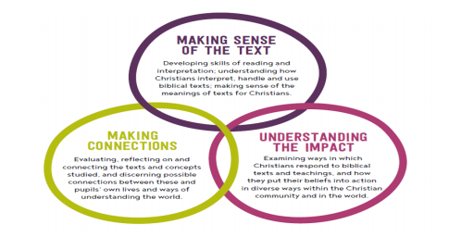

The Oxford Diocesan syllabus is used alongside Understanding Christianity to ensure that children are given opportunities to explore a wide range of different religions throughout their time in Primary School using the ‘Big Questions’ the children are encouraged to discovery for themselves. The Engage, Enquire, Evaluate and Reflect model of teaching does not have to progress in a linear fashion, nor does each section have to be touched on only once, but can be revisited at any point during a unit of work. There should also be scope to leave the plans behind if the pupils’ questioning and investigating opens up other interesting avenues for enquiry. Where special events occur (WW1 remembrance for example) a unit of work may need to be adapted or abandoned. It is important that whenever the children are given the opportunity to reflect on what they have learned, they are considering what difference their learning is making to their thinking and acting.

Example overview
It is through using these two schemes alongside each other that we are providing children with a holistic and balanced RE curriculum. We use a variety of teaching methods including art, music, discussion, the development of thinking skills, drama, the use of artefacts, pictures, stories, and the use of reflection.
Following a secure foundation of knowledge gained of other faiths lower down the school, the final two years are spent exploring themes such as morality and life journeys. This is explored through religious and non-religious points of views leading to the foundations of philosophy and ethics understanding. This is an important introduction as this is a subject taught at Key Stage 3 and 4 within our academy trust.
How do we measure the impact of the RE Curriculum?

By the time children leave our school they will:
- Ask and offer possible answers to challenging questions about the meaning of life, beliefs, nature of reality and morality.
- Have a secure understanding and knowledge of the religions studied and be confident to answer ultimate questions.
- Have the ability to ask significant and reflective questions about religion and demonstrate a good understanding of issues relating to the nature, truth and value of religion.
- Have a sense of self, identity and belonging to flourish within the community and be responsible citizens.
- Show respect, tolerance and understanding of all religions and beliefs.
- Have a strong understanding of how the beliefs, values, practices and ways of life within any religion come together.
- The ability to link the study of religion and belief to personal reflections on meaning and purpose.
- The ability to exemplify the School’s Christian values in all aspects of life that are rooted in the teachings of the Bible.
- Have started to engage in philosophical debates and tackle issues of ethics.
RE Subject Leader Monitoring investigates over a year:
QET Curriculum Principle | Examples of success | Where will they find this?
Sequenced? | - Is key knowledge logically-ordered?  - Are lessons being built on what came before? | - Book scrutiny  - Internal moderation  - Learning walks/ drop ins
Motivating? | - Are children engaging in deeper thinking?  - Do they enjoy discussions around the themes? | - Pupil voice  - Sparkling starts
Ambitious? | - Is ‘going deeper’ being accessed by classes?  - Are children reading widely and for fun about RE? | - Book scrutiny  - Internal moderation  - Learning walks/ drop ins  - Data
Responsive? | - Do lessons deviate from the plan?  - Are lessons planned from what is needed using the Understanding Christianity assessment format? | - Book scrutiny  - Working walls  - Learning walks/ drop ins
Transformative? | - Are children more in awe about their world?  - Have children gone on to do something in their own time on this? | - Pupil voice  - Fabulous Finish  - Data

MUSIC
Music Curriculum Intent
Why is the Music Curriculum important at Spaxton?
“Music gives a soul to the universe, wings to the mind, flight to the imagination and life to everything.” Plato
“Music education can help spark a child's imagination or ignite a lifetime of passion. When you provide a child with new worlds to explore and challenges to tackle, the possibilities are endless. Music education should not be a privilege for a lucky few, it should be a part of every child's world of possibility.” Hillary Clinton
At Spaxton, children gain a firm understanding of what music is through listening, singing, playing, evaluating and composing across a wide variety of historical periods, styles, traditions, and musical genres. We are committed to ensuring children understand the value and importance of music to their own and others’ lives and wellbeing and also the impact music has in the wider community. All children have access to music regardless of their academic ability, race, ethnicity, background and language. SEND pupils are actively encouraged to participate fully as music is often an area of the curriculum which allows them to excel. We aim to provide children with the opportunity to progress to the next level of their creative excellence.

How is the Music Curriculum implemented?

This is currently planned using the agreed objectives from our schemes of work and delivered either discretely or through the cross-curricular topic.
How do we measure the impact of the Music Curriculum?
Music Subject Leader Monitoring investigates over a year:
QET Curriculum Principle | Examples of success | Where will they find this?
Sequenced? | - Is key knowledge logically-ordered?  - Is there a mix of appraising, composing and performing? | - Internal moderation  - Working walls  - Learning walks/ drop ins
Motivating? | - Are children independent?  - Do children enjoy their music lessons? | - Pupil voice  - Sparkling starts
Ambitious? | - Are the key musical elements being taught?  - Are children reading widely and for fun about Music? | - work scrutiny  - Internal moderation  - Working walls  - Learning walks/ drop ins  - Data
Responsive? | - Do lessons deviate from the plan?  - Are lessons planned from what is needed using the disciplinary knowledge overview? | - Work scrutiny  - Working walls  - Learning walks/ drop ins
Transformative? | - Are children more confident in their Music knowledge?  - Have children gone on to do something in their own time on this? | - Pupil voice  - Fabulous Finish  - Memory morning  - Data
HISTORY
History Curriculum Intent
Why is the History Curriculum important at Spaxton?

At Spaxton, it is our aim to instil a love of History in all our children. We aim to provide a history curriculum with appropriate subject knowledge, skills and understanding as set out in the National Curriculum History Programmes of study. We aim to provide an interesting and varied curriculum that interests and intrigues our children while meeting the needs of all backgrounds, cultures and abilities.
From EYFS up to the end of KS2, the children will be taught about various historical events, where they take place within a historical timeline and famous historical figures, some of which have shaped the world today. As well as valuing knowledge of world history, British History is important so that children understand more about this country’s background. We also carefully sequence knowledge so that children go onto discover the history of the church in Key Stage 3 within our academy trust as we believe it is important that they also understand the church’s place in our country.

How is the History Curriculum implemented?
This is currently planned using the agreed objectives from our schemes of work and delivered either discretely or through the cross-curricular topic.
How do we measure the impact of the History Curriculum?
History Subject Leader Monitoring investigates over a year:
QET Curriculum Principle | Examples of success | Where will they find this?
Sequenced? | - Is key knowledge logically-ordered?  - Do children have a sense of chronology? | - Book scrutiny  - Internal moderation  - Working walls  - Learning walks/ drop ins
Motivating? | - Are children independent?  - Do they talk passionately about the past? | - Pupil voice  - Sparkling starts
Ambitious? | - Is sufficient progress being made in key history concepts?  - Are children reading widely and for fun about History? | - Book scrutiny  - Internal moderation  - Working walls  - Learning walks/ drop ins  - Memory morning  - Data
Responsive? | - Do lessons deviate from the plan?  - Are lessons planned from what is needed using the disciplinary knowledge overview? | - Book scrutiny  - Working walls  - Learning walks/ drop ins
Transformative? | - Can children link knowledge in history?  - Have children gone on to do something in their own time on this? | - Pupil voice  - Fabulous Finish  - Memory morning  - Data

GEOGRAPHY
Geography Curriculum Intent
Why is the Geography Curriculum important at Spaxton?

It is our intent for the Geography element of our school curriculum to inspire pupils with a curiosity and fascination about the world and its people that will remain with them for the rest of their lives.
Teaching should equip pupils with knowledge about diverse places, people, resources and natural and human environments, together with a deep understanding of the Earth’s key physical and human processes. By revisiting these areas of learning regularly children will remember more, know more and understand more. As pupils progress, their growing knowledge about the world should help them to deepen their understanding of the interaction between physical and human processes, and of the formation and use of landscapes and environments. We want our children to gain confidence and have practical experiences of geographical knowledge, understanding and skills that explain how the Earth’s features at different scales are shaped, interconnected and change over time.

How is the Geography Curriculum implemented?
This is currently planned using the agreed objectives from our schemes of work and delivered either discretely or through the cross-curricular topic.
How do we measure the impact of the Geography Curriculum?
Geography Subject Leader Monitoring investigates over a year:
QET Curriculum Principle | Examples of success | Where will they find this?
Sequenced? | - Is key knowledge logically-ordered?  - Do children have a sense of place? | - Book scrutiny  - Internal moderation  - Working walls  - Learning walks/ drop ins
Motivating? | - Are children independent?  - Do they talk passionately about Geography? | - Pupil voice  - Sparkling starts
Ambitious? | - Is sufficient progress being made in key Geographical concepts?  - Are children reading widely and for fun about Geography? | - Book scrutiny  - Internal moderation  - Working walls  - Learning walks/ drop ins  - Memory morning  - Data
Responsive? | - Do lessons deviate from the plan?  - Are lessons planned from what is needed using the disciplinary knowledge overview? | - Book scrutiny  - Working walls  - Learning walks/ drop ins
Transformative? | - Can children link knowledge in geography?  - Have children gone on to do something in their own time on this? | - Pupil voice  - Fabulous Finish  - Memory morning  - Data

ART & DESIGN

Art & Design Curriculum Intent
Why is the Art & Design Curriculum important at Spaxton?
At Spaxton, art should be fully inclusive to every child. Our aims are to: fulfil the requirements of the National Curriculum for art and design, provide a broad and balanced curriculum, ensure the progressive development of knowledge and skills, enable children to observe and record from first-hand experience and from imagination, develop the children’s competence in controlling materials and tools, acquire knowledge and become proficient in various art and design techniques and processes, begin to develop an awareness of the visual and tactile elements including; colour, pattern and texture, line and tone, shape, form and space, foster enjoyment and appreciation of the visual arts and develop a knowledge of significant artists, craftspeople and designers, increase critical awareness of the roles and purposes of art and design in different times and cultures, and analyse works using the language of art and design and develop a cross-curricular approach to the use of art and design in all subjects.
Art and design teaching at Spaxton instils an appreciation and enjoyment of the visual arts. Art and design stimulates imagination and creativity; involving children in a range of visual, tactile and sensory experiences, which enable them to communicate what they see, think and feel through the use of the elements of colour, texture, line, form and pattern. Art and design promotes careful observation and an appreciation of the world around us. Children explore ideas and meanings through studying the work of artists and designers. Through learning about the roles and functions of art, they can explore the impact it has had on contemporary life and on different periods and cultures.
The aims of teaching art and design in our school are:
· To engage, inspire and challenge pupils, equipping them with the knowledge and skills to experiment, invent and create their own works of art, craft and design.
· As pupils progress through school, they should begin to think critically and develop a more rigorous understanding of art and design. They should also know how art and design both reflect and shape our history, and contribute to the culture, creativity and wealth of our nation.
· To produce creative work, exploring their ideas and recording their experiences.
· To become proficient in drawing, painting, sculpture and other art, craft and design techniques
· To evaluate and analyse creative works using the language of art, craft and design.
· To know about great artists, craft makers and designers, and understand the historical and cultural development of their art forms.

How is the Art & Design Curriculum implemented?
This is currently planned using the agreed objectives from our schemes of work and delivered either discretely or through the cross-curricular topic.

How do we measure the impact of the Art & Design Curriculum?
Art and Design Subject Leader Monitoring investigates over a year:
QET Curriculum Principle | Examples of success | Where will they find this?
Sequenced? | - Is key knowledge logically-ordered?  - Are the children developing high quality pieces of Art? | - Book scrutiny  - Internal moderation  - Working walls  - Learning walks/ drop ins
Motivating? | - Are children independent?  - Are they encouraged to be creative? | - Pupil voice  - Sparkling starts
Ambitious? | - Is sufficient progress being made in the artistic elements?  - Are children reading widely and for fun about Art and Art History? | - Book scrutiny  - Internal moderation  - Working walls  - Learning walks/ drop ins  - Memory morning  - Data
Responsive? | - Do lessons deviate from the plan?  - Are lessons planned from what is needed using the disciplinary knowledge framework? | - Book scrutiny  - Working walls  - Learning walks/ drop ins
Transformative? | - Are children more confident in their Art knowledge?  - Have children gone on to do something in their own time on this? | - Pupil voice  - Fabulous Finish  - Data

DESIGN & TECHNOLOGY

Design & Technology Curriculum Intent
Why is the Design & Technology Curriculum important at Spaxton?
Design and Technology is an inspiring, rigorous and practical subject. Design and Technology encourages children to learn to think and intervene creatively to solve problems both as individuals and as members of a team. At Spaxton, we encourage children to use their creativity and imagination, to design and make products that solve real and relevant problems within a variety of contexts, considering their own and others’ needs, wants and values. We aim to, wherever possible, link work to other disciplines such as mathematics, science, engineering, computing and art. The children are also given opportunities to reflect upon and evaluate past and present design technology, its uses and its effectiveness and are encouraged to become innovators and risk-takers.

How is the Design & Technology Curriculum implemented?
Each unit of work is taught discreetly or through our topic based approach taking approximately 6 weeks to complete and is based around the disciplinary knowledge in our progressions document around three themes:
- Design
- Make
- Review
Each unit focuses on either Food Technology, Materials or Product Design. The children are set a challenge to innovate a new product for a real purpose so that the academic rigor is there as well as to motivate.
How do we measure the impact of the Design & Technology Curriculum?
Design & Technology Subject Leader Monitoring investigates over a year:
QET Curriculum Principle | Examples of success | Where will they find this?
Sequenced? | - Is key knowledge logically-ordered?  - Are the children being innovative in solving real problems? | - Book scrutiny  - Internal moderation  - Working walls  - Learning walks/ drop ins
Motivating? | - Are children independent?  - Are they encouraged to be creative? | - Pupil voice  - Sparkling starts
Ambitious? | - Is sufficient progress being made in cooking, construction and CAD?  - Are children reading widely and for fun about DT/ STEM? | - Book scrutiny  - Internal moderation  - Working walls  - Learning walks/ drop ins  - Memory morning  - Data
Responsive? | - Do lessons deviate from the plan?  - Are lessons planned from what is needed using the disciplinary knowledge framework? | - Book scrutiny  - Working walls  - Learning walks/ drop ins
Transformative? | - Are children more confident in their DT skills?  - Have children gone on to do something in their own time on this? | - Pupil voice  - Fabulous Finish  - Memory morning  - Data
RELATIONSHIPS, Social & HEALTH EDUCATION (RSHE)
Why is the RSE Curriculum important at Spaxton?
We believe that promoting the health and well-being of our pupils is an important part of their overall education. We do this through our Personal, Social and Health Education (PSHE) course. This looks at many topics including all kinds of relationships, physical/emotional health and living in the wider world. The aim of the PSHE course is to help our pupils make safe and informed decisions during their school years and beyond.
Relationship and Sex Education (RSE) is an important part of the PSHE course. We will be teaching lessons about RSE in the second half of the Summer term.
During the course, pupils will be able to ask questions, which will be answered factually and in an age appropriate manner. Each pupil's privacy will be respected, and no one will be asked to reveal personal information.
Some parts of RSE are compulsory - these are part of the National Curriculum for Science. Some parts of the sex education is not compulsory. However, we believe that the presentation of sexual images in social and other media make it important that all young people have a place to discuss pressures, check facts and dispel myths. Even if a child is withdrawn, many pupils will discuss such issues with each other outside the classroom – so, rather than hear about the content second-hand, we hope all children will have the opportunity to take part in our carefully planned lessons.
Many parents and parent-related organisations support good quality RSE in school. Parents are the most important educators of young people in personal issues and many welcome the support that school can offer to supplement their home teaching.

How is the RSE Curriculum implemented?
What will each year group be learning?

By the end of EYFS | - to understand what personal responsibility is.  - to value their body, including physical achievements and capabilities. (This lesson focuses on changes that happen throughout life. Children are asked to put pictures of people in age order. They then focus on themselves from birth to now, what has their body achieved- walking, riding a bike etc.​)  - to know the adults who are responsible for looking after them.​  - ​to understand basic hygiene routines, including toileting and washing.
Year 1 | - that family is one of the groups they belong to, as well as, for example, school, friends, clubs  - about the different people in their family / those that love and care for them  - that their family members, or people that are special to them, do to make them feel loved and cared for  - how families are all different but share common features – what is the same and different about them  - about different features of family life, including what families do / enjoy together  - that it is important to tell someone (such as their teacher) if something about their family makes them feel unhappy or worried
Year 2 | - to discuss what they like/dislike and are good at  - what makes them special and how everyone has different strengths  - how their personal features or qualities are unique to them  - how they are similar or different to others, and what they have in common  - to use the correct names for the main parts of the body, including external genitalia; and that parts of bodies covered with underwear are private
Year 3 and 4 | - how friendships support wellbeing and the importance of seeking support if feeling lonely or excluded  - how to recognise if others are feeling lonely and excluded and strategies to include them  - how to build good friendships, including identifying qualities that contribute to positive friendships  - that friendships sometimes have difficulties, and how to manage when there is a problem or an argument between friends, resolve disputes and reconcile differences  - how to recognise if a friendship is making them unhappy, feel uncomfortable or unsafe and how to ask for support  - that their body belongs to them and should not be hurt or touched without their permission; what to do and who to tell if they feel uncomfortable
Year 5 and 6 | - about puberty and how bodies change during puberty, including menstruation and menstrual wellbeing, erections and wet dreams  - how puberty can affect emotions and feelings  - how personal hygiene routines change during puberty  - how to ask for advice and support about growing and changing and puberty
- how to recognise and respect similarities and differences between people and what they have in common with others
- that there are a range of factors that contribute to a person’s identity (e.g. ethnicity, family, faith, culture, gender, hobbies, likes/dislikes)
- how individuality and personal qualities make up someone’s identity (including that gender identity is part of personal identity and for some people does not correspond with their biological sex)
- that people have different kinds of relationships in their lives, including romantic or intimate relationships
- that people who are attracted to and love each other can be of any gender, ethnicity or faith; the way couples care for one another
- that adults can choose to be part of a committed relationship or not, including marriage or civil partnership
- that marriage should be wanted equally by both people and that forcing someone to marry against their will is a crime
- how puberty relates to growing from childhood to adulthood
Year 6 | - that people have different kinds of relationships in their lives, including romantic or intimate relationships  - that people who are attracted to and love each other can be of any gender, ethnicity or faith; the way couples care for one another  - that adults can choose to be part of a committed relationship or not, including marriage or civil partnership  - that marriage should be wanted equally by both people and that forcing someone to marry against their will is a crime  - how puberty relates to growing from childhood to adulthood  - about the reproductive organs and process - how babies are conceived and born and how they need to be cared for  - that there are ways to prevent a baby being made  - how growing up and becoming more independent comes with increased opportunities and responsibilities  - how friendships may change as they grow and how to manage this  - how to manage change, including moving to secondary school; how to ask for support or where to seek further information and advice regarding growing up and changing

How do we measure the impact of the RSE Curriculum?
QET Curriculum Principle | Examples of success | Where will they find this?
Sequenced? | - Is key knowledge logically-ordered?  - Are the children able to build on prior learning | - Work scrutiny  - Working walls  - Learning walks/ drop ins
Motivating? | - Are children independent?  - Are the children seeking own ways to promote their well-being | - Pupil voice
Ambitious? | - Is sufficient progress being made?  - Are children displaying an increasing disciplinary knowledge and skills for life? | - work scrutiny  - Learning walks/ drop ins  - Data
Responsive? | - Do lessons deviate from the plan?  - Are lessons planned from what is needed using the national curriculum? | - Work scrutiny  - Working walls  - Learning walks/ drop ins
Transformative? | - Are children more confident in their understanding of themselves and others?  - Have children gone on to do something in their own time on this? | - Pupil voice  - Impact/data

