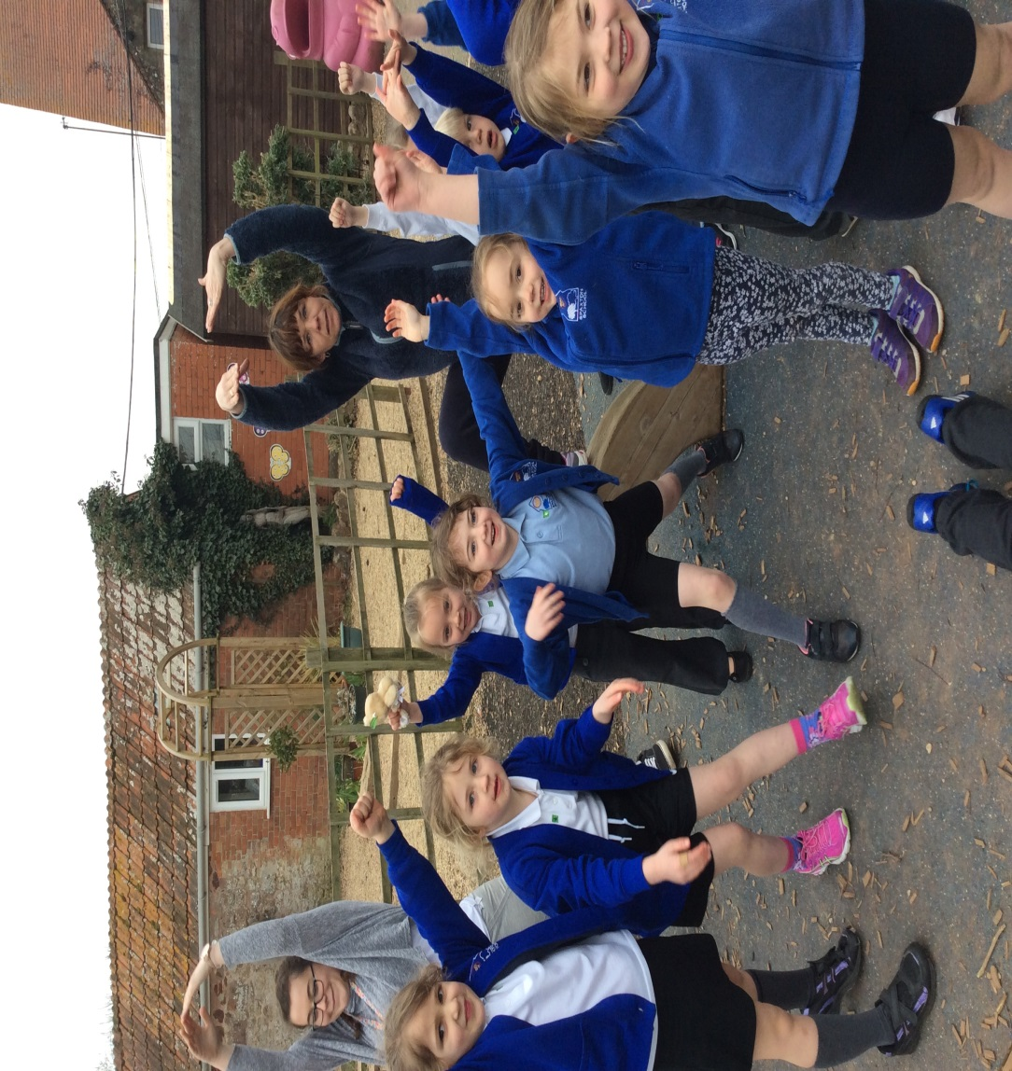 |  | Spaxon CE VC Primary School  - Newsletter  - May 2016
protect, trust, have hope, persevere, show courage and rejoice… |  | Spaxton news bites

I am finding it hard to believe that we are in our final term of the year. It doesn’t seem two minutes ago that I was preparing for my transition to Spaxton School and here we are, in May, preparing for further transitions in readiness for a new academic year! All over the school there are pockets of pupils and staff that have, in some way, a transition to make in the coming term.
For Year 6 they have one term left of their primary school lives; one term to showcase their academic talent through their SATs and prepare for the next step in their journey by transitioning to secondary school.
For other children it may be having a new teacher in Mr Kelly or Mr Haddell or even the fact that there have just been a few changes this year that have needed some transition time. This is, of course, in addition to the new reception children that will be starting in September.

Whoever you are, there have been and will continue to be stages of transition during the year and with this comes testing and challenging moments. As a school, we have started looking at perseverance and have talked about Nehemiah who, in the Bible, faced scorn for rebuilding the walls and gates of Jerusalem but persevered because he knew what he had to do in order to ‘get the job done.’

Like Nehemiah, I can see staff and children all over the school, on a daily basis, doing what they need to do ‘to get the job done.’ Whether it’s Year 6s preparing for upcoming tests, Class 2 being put through their paces by Mr Kelly or the countless other children who are striving to make the next step in their learning. Like Nehemiah, I am proud to look upon the great building work that has taken place.

It’s that time of year again…
Thoughts of a Headteacher – Mr. Blackmore
Thank You!
We are very pleased to announce that we raised £120 for Sports Relief, last term. We all had a very active day that included running a Sports Relief Mile around the perimeter of our field. The picture (top left) shows Class One warming up before the run!
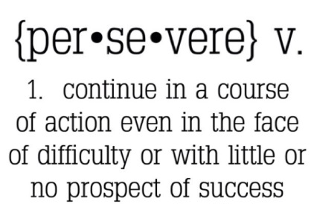
‘Vision and Values’
Our vision and values theme for this half term is ‘perseverance.’ This is a very apt theme for this half term as it can be a time when we are truly tested. We are thinking about how we can be resilient in the face of adversity…

Curriculum Focus
In this section we will look at a different aspect of the National Curriculum.
Adverbs
Adverbs are one of the eight parts of speech.
They explain a bit more about the activity being described.
So, in the sentence, ‘I walked to school,’ you could insert an adverb to say ‘I walked carefully to school’ or ‘I walked happily to school.’

The adverb is modifying the verb to describe the action.

If you add to that sentence to say ‘I walked very happily to school’, you’ll be modifying the adverb ‘happily’ with another adverb, ‘very’. Also, in the sentence, ‘I’m sleepy,’ you can

include an adverb to describe how sleepy – ‘I’m extremely sleepy’ or ‘I’m moderately sleepy’. The adverb is modifying the adjective here.

I would enjoy seeing any work done on adverbs, at home!
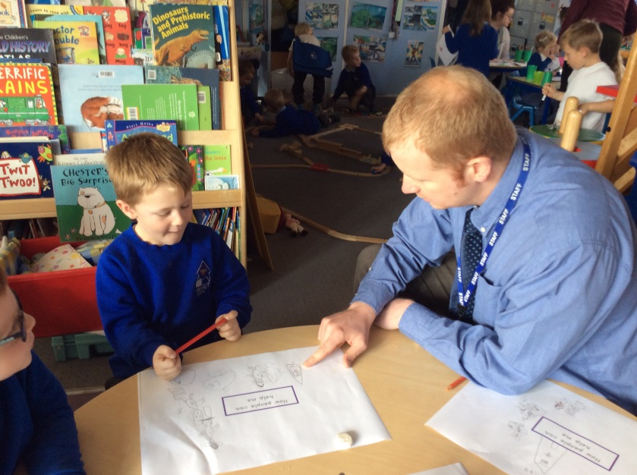

Quote of the month
Education is the most powerful weapon which you can use to change the world.
Nelson Mandela

Matthew Bates in Class 4 has completed all of his badges in Beavers and was initiated into Cubs by the Commissioner as a result. As you can see he has accomplished a number of badges with the 1st North Petherton Cubs over the last two years, most of which he does at home with the help of his Mum and friends and on occasion with school.
He will begin 1st North Petherton Scouts next week (much to his sister's

Well done Matthew!

annoyance - who also attends!) and is so excited about it and has already completed his Scout Swimmer badge in anticipation.
I'm sure he'll tell you anything else you want to know about his experience with the Scouting association.
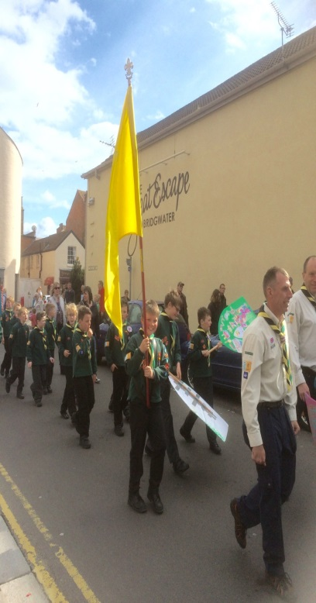
If you have any news that can be celebrated, please send a photo and write-up to the office email address.

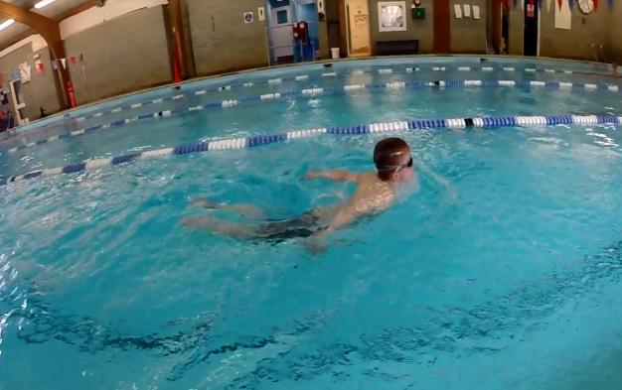
Reminders
Austin Ranson (Class 2) participating in his swimming camp during the Easter holidays. Well done Austin!
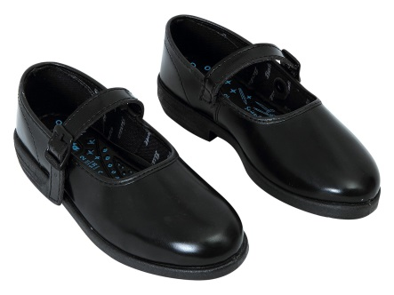
School Uniform
Whilst I am proud of the individuality that our approach to school uniform encourages, I would just like to tighten up on only ensuring that blue that is present is a ‘royal’ blue. Can I also ask that footwear is smart and appropriate for school. In addition to this, in the coming summer months, please ensure that any summer footwear covers toes and keeps feet safe.

Meet Mr. Kelly!

Friday Family First
Please join us this Friday (6th) for our Family First Service at the church. As usual, the service commences at 2.45pm and collection of the children is from the church after the service has finished.

May Calendar
May 3rd – KS1 SATs window opens
May 5th – Family Friday First Service
May 9th – KS2 SATs week
May 13th – PTFA Family Rounders
May 16th – Rounders tournament
May 17th – YR and 6 Heights and Weights
May 24th – School Photo (TBC)
May 25th – Rounders tournament

June 7th – Bags for Schools (more info to follow)

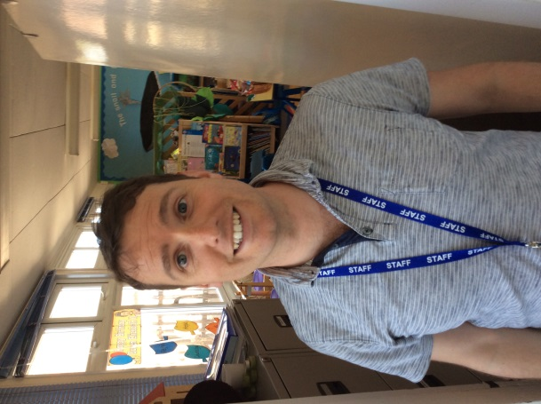
You may have seen him around but who is Mr Kelly? We sent Lillia Hooper and Ellie Hooper to investigate. Find out what happened in next month’s edition.

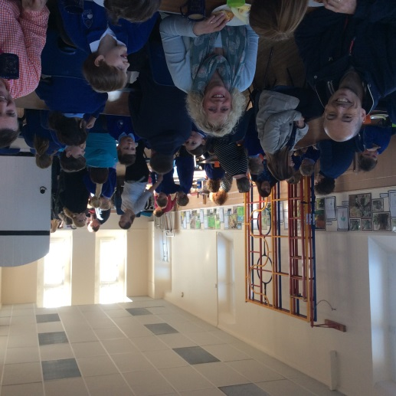
French Breakfast Success!

PTFA Newsletter
May 2016

We would like to say thank you for all those who attended the French Breakfast. It was a great success and it was lovely to see so many of our school community enjoying the start of a day together…

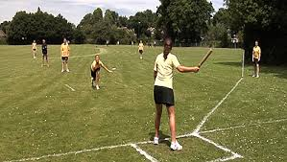
Family Rounders and Rug Sale
A reminder that we are having a family rounders and rug sale on Friday 13th May. Please do join us for an afternoon of fun – see advertised posters for further details.

PLEASE JOIN OUR FACEBOOK PAGE TO BE KEPT UP-TO-DATE WITH FUTURE EVENTS!

