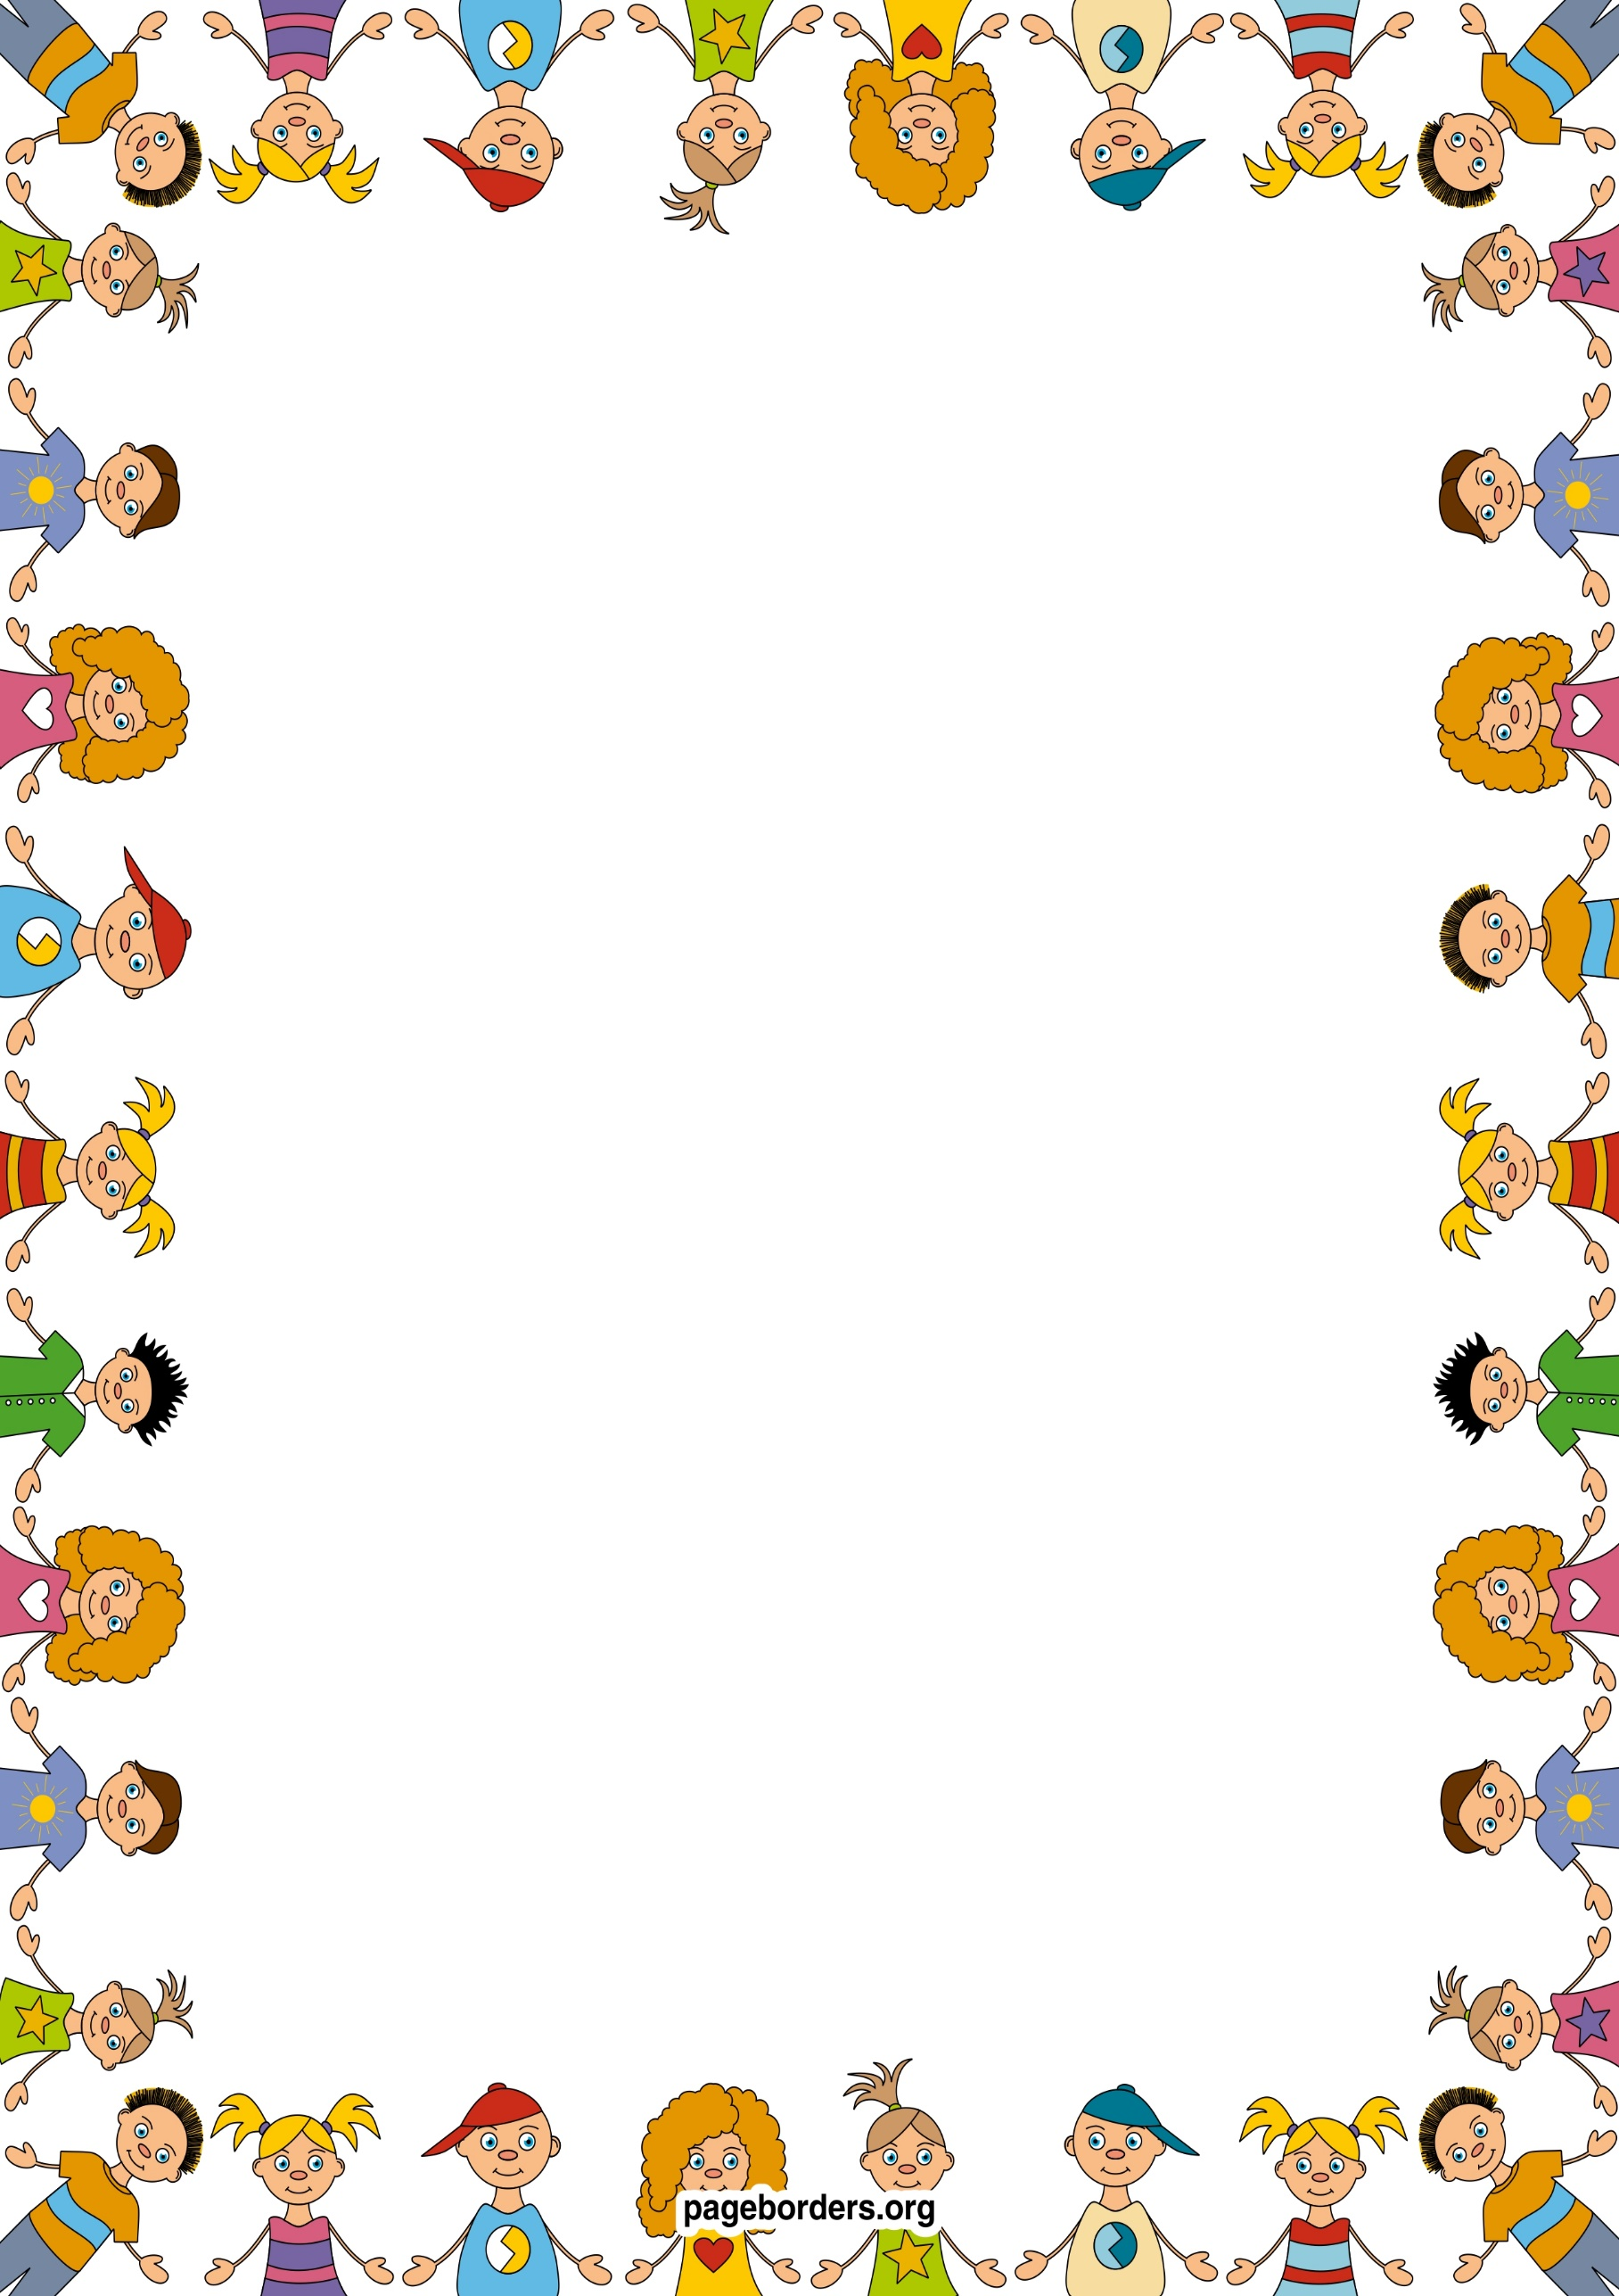

Marvellous Me Our 2 week project

**Wellbeing and Mental health**

* I will be learning mindfulness techniques to help me relax and calm
* I will learn about others through sharing experiences
* I will be learning the routines of the school day
* I will be creating class rules with my friends.
* I will be trying out new activities independently
* I will be participating in team games/yoga activities
* I will be learning to think about the feelings of others
* I will be learning and talking about my family and other people who are important to me

## English

* I will be writing about myself and my family
* I will be writing for a variety of purposes.
* I will be listening to a range of texts
* I will be reading a range of fiction /non-fiction books
* I will be practising my handwriting
* I will learning spelling patterns and rules

## Physical Education (PE)

* I will be working together as a team
* I will be using equipment safely
* I will be learning about how to be healthy
* I will be describing the changes my body after being active.

**Topic based – through Computing/Sci/Geog**

* I will be using digital cameras to take photos of my friends
* I will be using a computer to help me in my learning.
* I will be using all five senses to investigate area around them
* I will be recognising similarities and differences between each other
* I will be going on local walks around the school to find out about our local area where we live and go to school
* I will be learning about different parts of the body as well as naming them in French

## Art & Design

* I will be drawing pictures of myself using mirrors.
* I will be drawing pictures of my family
* I will be thinking about colours and using them appropriately in my pictures.
* I will be using clay to recreate my face

## Mathematics

* I will be comparing myself, my friends and family and putting my findings into simple graphs and tables
* I will be ordering the events in my day.
* I will be learning timetables through song