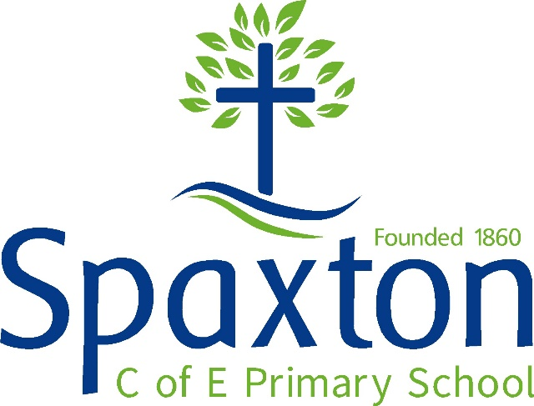

CURRICULUM POLICY

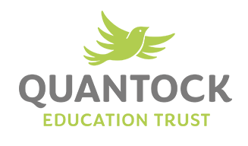

Approved by: |  | Date:
Last reviewed on:
Next review due by:

Our vision is: | “Together we flourish and achieve”
Our values are: | Protect, Trust, Have Hope, Persevere, Show Courage and Respect
Main Idea: Our children work together to flourish and achieve through our ‘small steps’ Curriculum

Curriculum Intent

Why is the curriculum important at Spaxton?

We recognise that our curriculum is a powerful tool in delivering our vision. We believe that children will have better health and wellbeing if they are successful. Successful children know more. Knowledge leads to learning and this is something that we nurture and develop within our individuals in order to help them flourish.

This policy is based mainly on the work of Tom Sherrington (The Learning Rainforest), Debra Kidd (A Curriculum of Hope) and James Nottingham (Pit Learning). It is rooted in research, particularly around cognitive research and the expectation that learning content is to be remembered. It also meets the curriculum principles of our academy trust, the Quantock Education Trust.

In this policy, we refer to Sherrington's 'Hinterland'- the connected knowledge to the core knowledge to be gained. We want children to become autonomous to research and feel the desire to learn in greater depth. Although our topics are co-planned with partner school, (Stogursey) our children also have a large say in what they want to find out enabling them to take responsibility for their learning, our teachers and support staff sequence the learning carefully so that it builds in small steps. Research shows small steps mastery works well so that all children achieve. Our Pupil Premium Strategy, interventions and COVID catch up programme removes obstacles that may bar children from progressing. Our teaching and learning development programme is the main driver of success, as we believe that quality first teaching with a well-sequenced curriculum will deliver our vision.

What are the principles that underpin strong curriculum design at Spaxton?

- We deliver a strong and carefully Sequenced curriculum, so that children’s learning progresses in a way that builds knowledge intentionally and cumulatively – with children being secure in their learning and able to achieve age-related milestones. Vocabulary, oracy, reading and character are developed alongside knowledge as vital components of our curriculum.
- We deliver a curriculum that Motivates children so they are compelled to make the discretionary effort required to achieve their potential because they see value and joy in learning. Children will learn that they have a voice, which sends the message that their ideas and thinking are relevant to the learning that takes place so they develop agency over their learning.
- We deliver an Ambitious curriculum, so that children are challenged and empowered to think deeply and critically, as well as being exposed to big ideas, research, enriching experiences, and powerful texts. They are expected to grapple with complexity, challenge assumptions, question accepted authorities and embrace curiosity.
- We deliver a curriculum that is Responsive, so that it meets the needs of children in our local community; is reviewed regularly; and supports children of all need and abilities to access all areas of the curriculum in order to excel.
- We deliver a curriculum that is Transformative, so that life choices are broadened as a result with children having the opportunity to pursue further study or hobbies to pursue whichever talents, passions and interests have been cultivated. Children can put their learning to use as active citizens, working for social justice, environmental stewardship and a healthy, equitable world, enabling them to build character and shape their future.

How is the curriculum implemented?

Our curriculum matches and exceeds the academic rigor of the National Curriculum (2014) for England and the Early Years Statutory Framework (2021). We believe the subject disciplines are the most effective way of delivering the knowledge and content of the National Curriculum. The EYSF is delivered through the 3 prime areas and 7 specific areas with an appropriate ratio of adult-led activities and child-led activities. The objectives are treated as outcomes to be achieved over time and not a list of activities to cover.

It is sequenced vertically, horizontally and diagonally. This ensures depth of learning and so that knowledge over time builds. Vertically (within a subject unit of work, phase-by-phase and by year group), horizontally (subjects linking together to give context to the learning and for relevance) and diagonally (subjects linking across each other and year groups and phases). Examples of this are below:
Sequence Type | Example | Starting point | Where it goes | Why?
Vertical | Maths | Mixed numbers and improper Fractions in Year 4 | Ordering fractions in Year 5 | Children need a sense of what this is before they can order the fractions explored in Year 5
Horizontal | English and Science | Reading good examples of formality in discussion texts (Year 5/6) | Writing a discussion in Science about the dilemma of giving blood displaying Scientific knowledge and progress in English. | Learning journeys need to make sense and be sequenced in the right order.
Diagonally | Geography (Lower Key Stage 2)  History (Upper Key Stage 2)  History (Key Stage 3) | Italy topic- learning about its importance in Europe and features. | Romans (UKS2)  The Church and State (KS3) | Children systematically gain knowledge so that it builds over time and so that they can move to higher order thinking, progressing quickly.

Vehicles of Delivery in our School

The content of our subjects are sequenced in these three ways but by being innovative, we are able to deliver this in small steps through three different vehicles:

- Discrete subjects- Subjects are taught in their own right and allocated regular time within the class timetables with occasional links made to other subjects where it works. The subjects classed as discrete are: English, Mathematics, Science, Computing, Modern Foreign Language, Physical Education, Relationships and Mental Health Education, Religious Education and Music.
- Topic- Teachers creatively plan linked studies across subjects and an exciting project is co-planned with the children. Subjects classed as topic are History, Geography, Science, Art, Design, and Technology. Each topic has either a History focus, Geography/ Science focus or Arts focus.

Sequencing Learning

The process teachers take to plan this is through loop planning. This can be found on loop planning walls in classrooms or unit plans in teacher files. Teachers take this process with planning the knowledge to be delivered and remembered:

- Know what is to be achieved by National Curriculum/ EYSF objectives- our schemes of learning outline the content
- Decide the substantive knowledge- Teachers collaborate across the trust with other generalists or specialists to decide key ideas for children to remember
- Plan the disciplinary knowledge to be learned- using their own assessments in each subject’s progression, Arbor data or pre-unit quizzes, teachers decide what is to be worked on
- Plan a ‘Sparkling Start’ and a ‘Fabulous Finish’- this is mainly for topics but can come into other subjects if necessary. Teachers also add in trips, experiences and the use of the wider community.
- Sequence learning in small steps (loops)- this is organic and responsive to children’s needs.
How do we measure the impact of the curriculum?
There are many ways to measure the impact of our curriculum but the main way is as in our school motto 'Together we flourish and achieve'. If children have done this, then we know it has made an impact. We mainly measure outcomes against national standards and at the end of Key Stage Summative Assessment points. Below are some of the ways we measure the success of our curriculum.
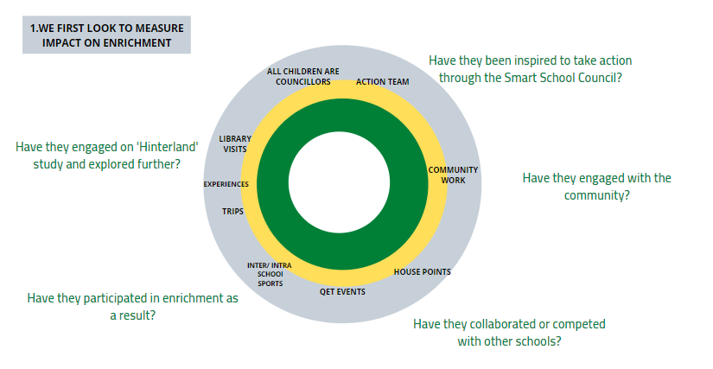
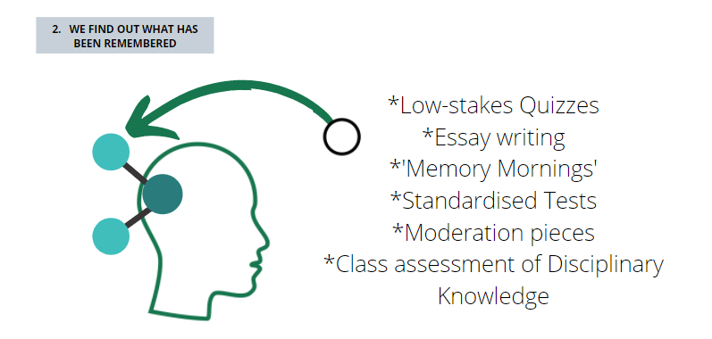

Key reflection questions Middle Leaders and Senior Leaders use to measure impact of curriculum in their monitoring of each term’s work:
- Was this well-Sequenced?
- Was this Motivating for children?
- Was this Ambitious?
- Was this Responsive?
- Was this Transformative?

SCHOOL SUBJECT LEADERS 2021/22

Subject | Person in charge
Communication, Language and Literacy (English) | Mrs R Skews
Mathematics | Mr K Atkins
Science | Mrs R Skews
Church distinctiveness and RE | Mr K Atkins
Early years/Foundation Stage (EYFS) | Miss E Shortland
Understanding the world (History/Geography) | Miss E Shortland
Relationships, social and health Education(RSHE) /Well being | Mrs R Skews
Expressive Arts (Music/Art and design) | Ms A Capel
Design Technology | Ms A Capel
Physical Development | Mr K Atkins
Modern Foreign Languages | Mrs R Skews
Computing | Mr Atkins
Outdoor learning | Ms A Capel

