Spaxton Church of England School
High Street, Spaxton, Somerset TA5 1BS

Headteacher: Mr James Blackmore

Tel:01278 671409
Fax:01278 671853
Website:www.spaxtonschool.co.uk
Email: spaxtonschool@educ.somerset.gov.uk

Wednesday 13th September, 2017
2016-2017 Parental Survey

Dear Parents,

At the end of the last academic year, many of you completed an online survey that would enable the school to set its improvement work for this academic year. The views of our stakeholders (pupils and parents) are of vital importance to us as we move forward and build on the many successes of last year.

As well as communicate the findings of the survey, I have added a small piece of commentary to each graph that outlines any possible explanation for the outcome of the survey question and what we plan to do to improve that particular area of school life.

Your views are very important to us. We hope you find this informative and thank you once again for taking the time to complete the survey.

Best wishes

Mr J. Blackmore
Headteacher
------------------------------------------------------------------------------------------------------------------------------------

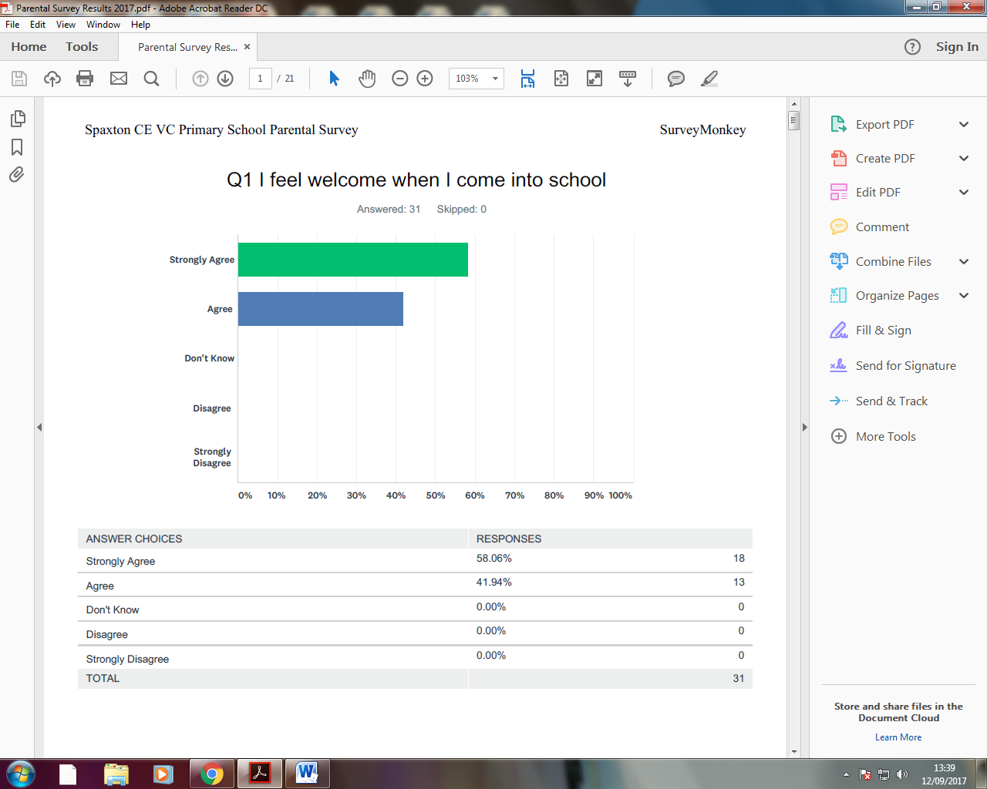
This is a pleasing response. We take great pride in the atmosphere of the school and parents feeling welcomed when they arrive on school premises is crucial to this.

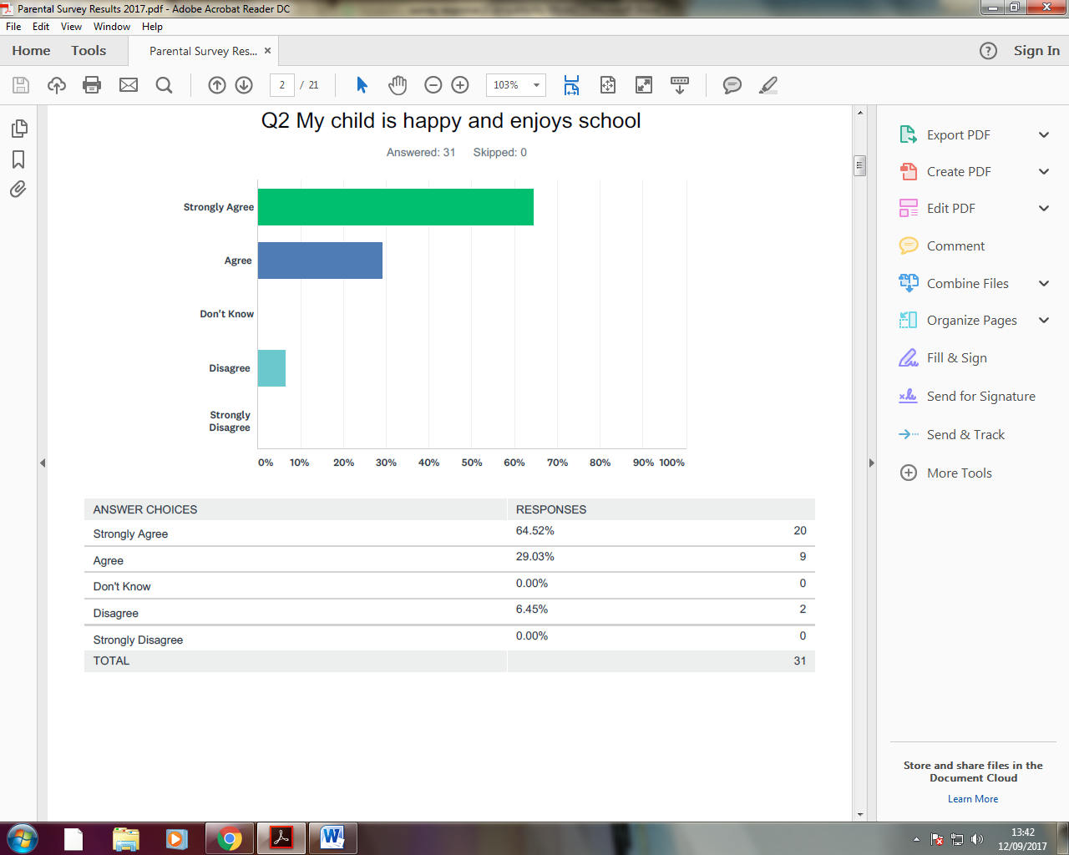
We’re glad to see so many of our children enjoy coming to school. We would very much advocate talking to class teachers, on a regular basis, about your child’s happiness in school so that they can help if there are issues that arise.

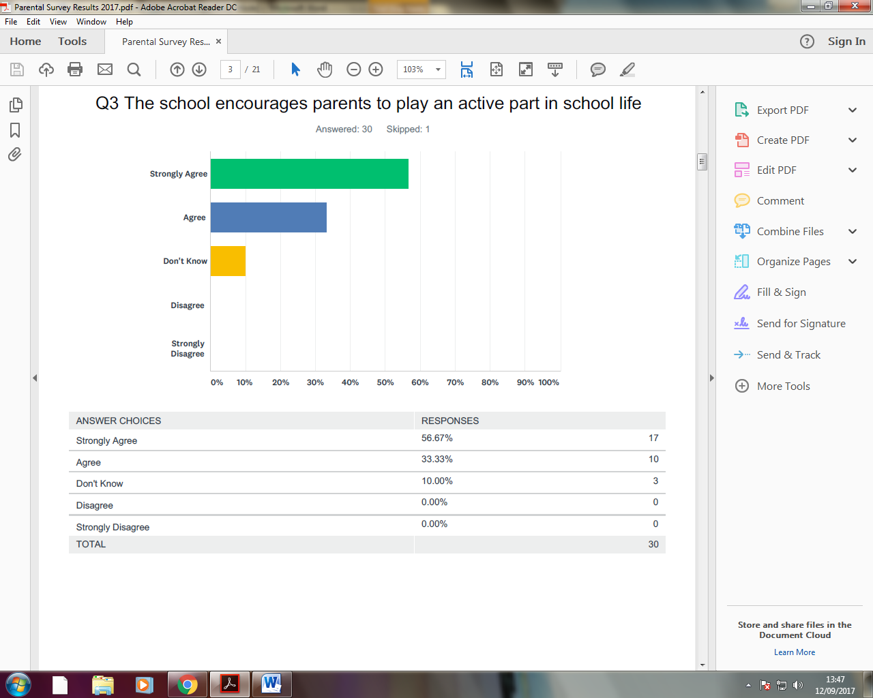
It is good to see that parents feel encouraged to play a part of school life. We did try to get a Parent Board off the ground eighteen months ago but to no avail. It is something that we would like to try again so that parents have a formal voice in the school.

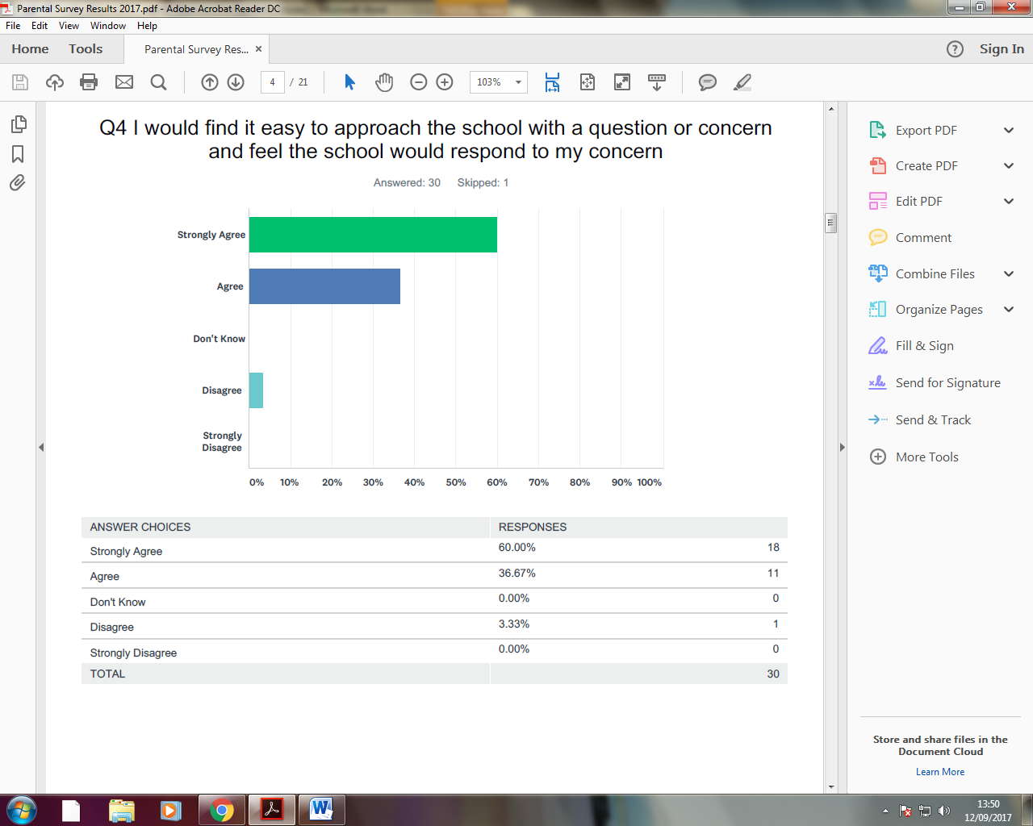
It’s pleasing that 97% of our parental community feel that they can approach the school with a problem and that it would be dealt with. We will continue to work hard to listen to your concerns and respond in a timely manner.

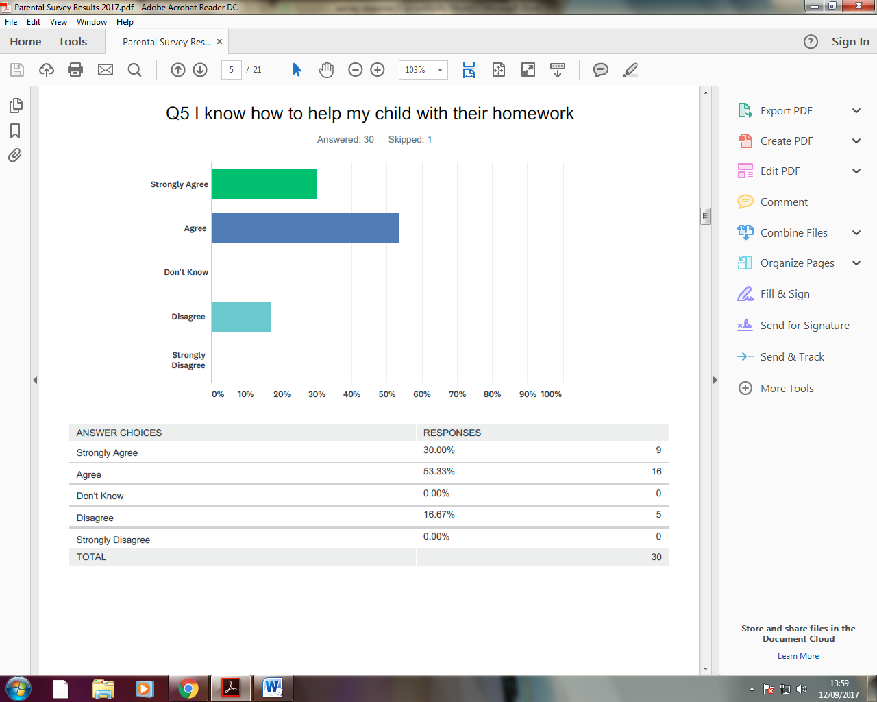

17% of our parental community are unsure as to how they can help with homework. This will form an action in this year’s School Development Plan (SDP). Workshops/information via our media streams has been pencilled in throughout the year.

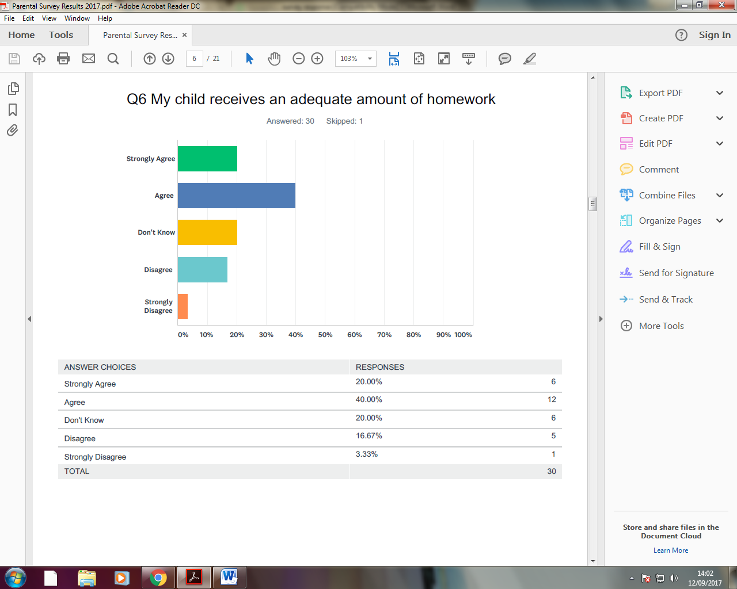
This is a tricky question because you could ‘strongly disagree’ that there is too much homework as much as you can about having too little homework. Regardless, this will form an action in this year’s SDP. We would very much like to dig a bit deeper with this by asking you to fill in a more detailed survey with a focus on purely homework.

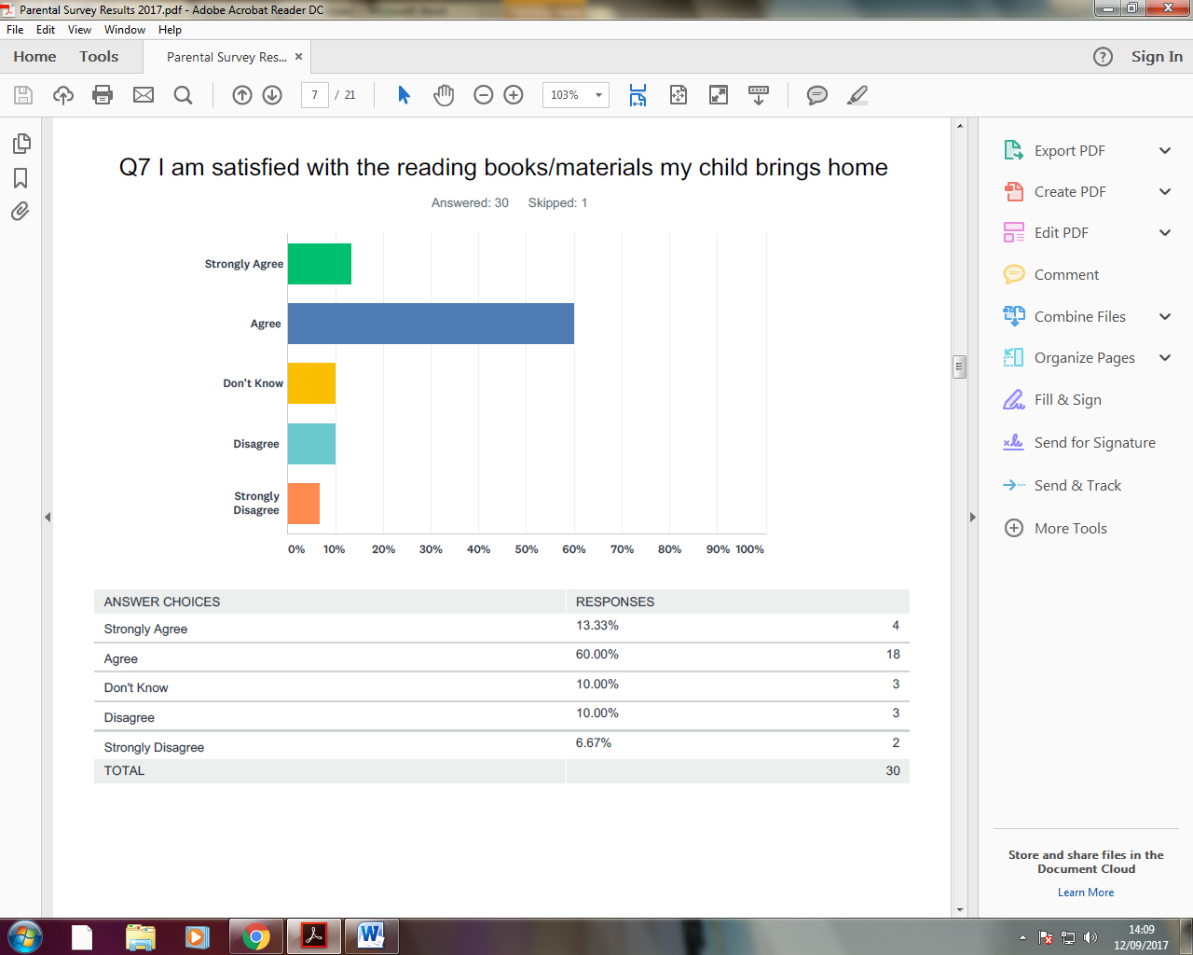
Although 73% of our parents are happy with reading materials, that still leaves a quarter unsure or unhappy with the materials given. This will form an action in this year’s SDP. We introduced a new reading scheme, last year, to ensure that it was in line with the new National Curriculum. As part of our English coordination, going forward, we will look at how improve /refine our delivery of reading for the home.

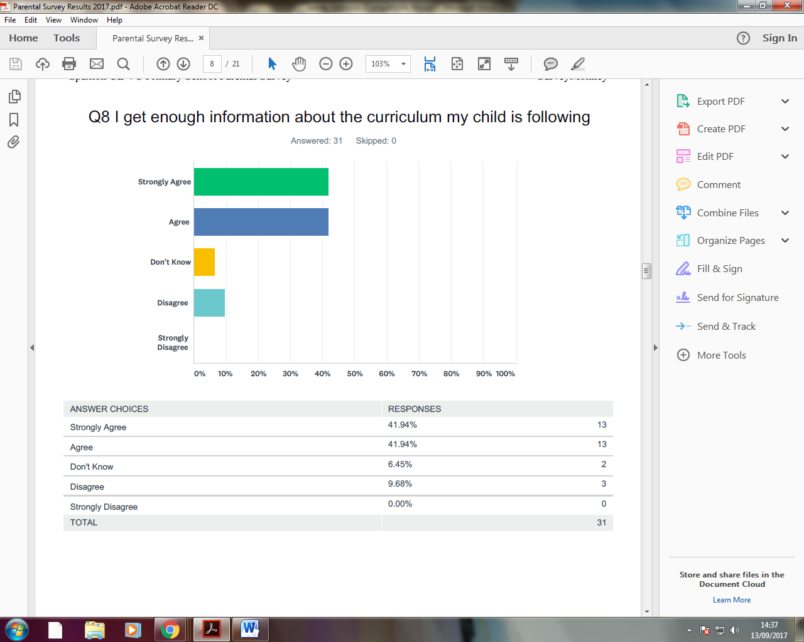
We send home curriculum overviews on a half termly basis and there is a growing amount of material on the website. In the newsletters we have attempted to feed information regarding the curriculum whether it is Marvin the Mathematical Monkey problems or demonstrating the progression in one particular curriculum area. I am aware that we could always do more to alert parents to curriculum information and will look to increase this as the year progresses.

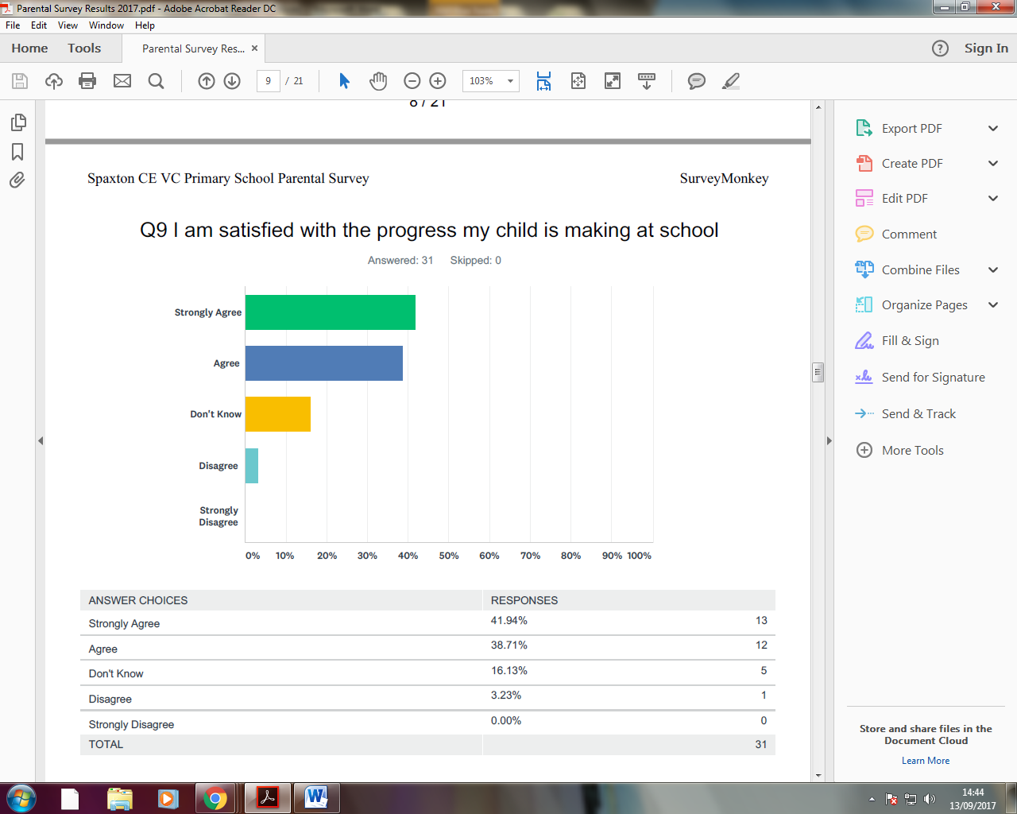
Over 80% of respondents are satisfied with the progress their child is making. Our progress measure at the end of KS2 has increased dramatically between 2016 and 2017. It is likely that our progress measure is in the top 10% of schools nationally.
We offer two parents’ consultations in the year in addition to timely progress reports and an end-of-year report. If you are still unsure or worried about your child’s progress, please do see your child’s teacher.

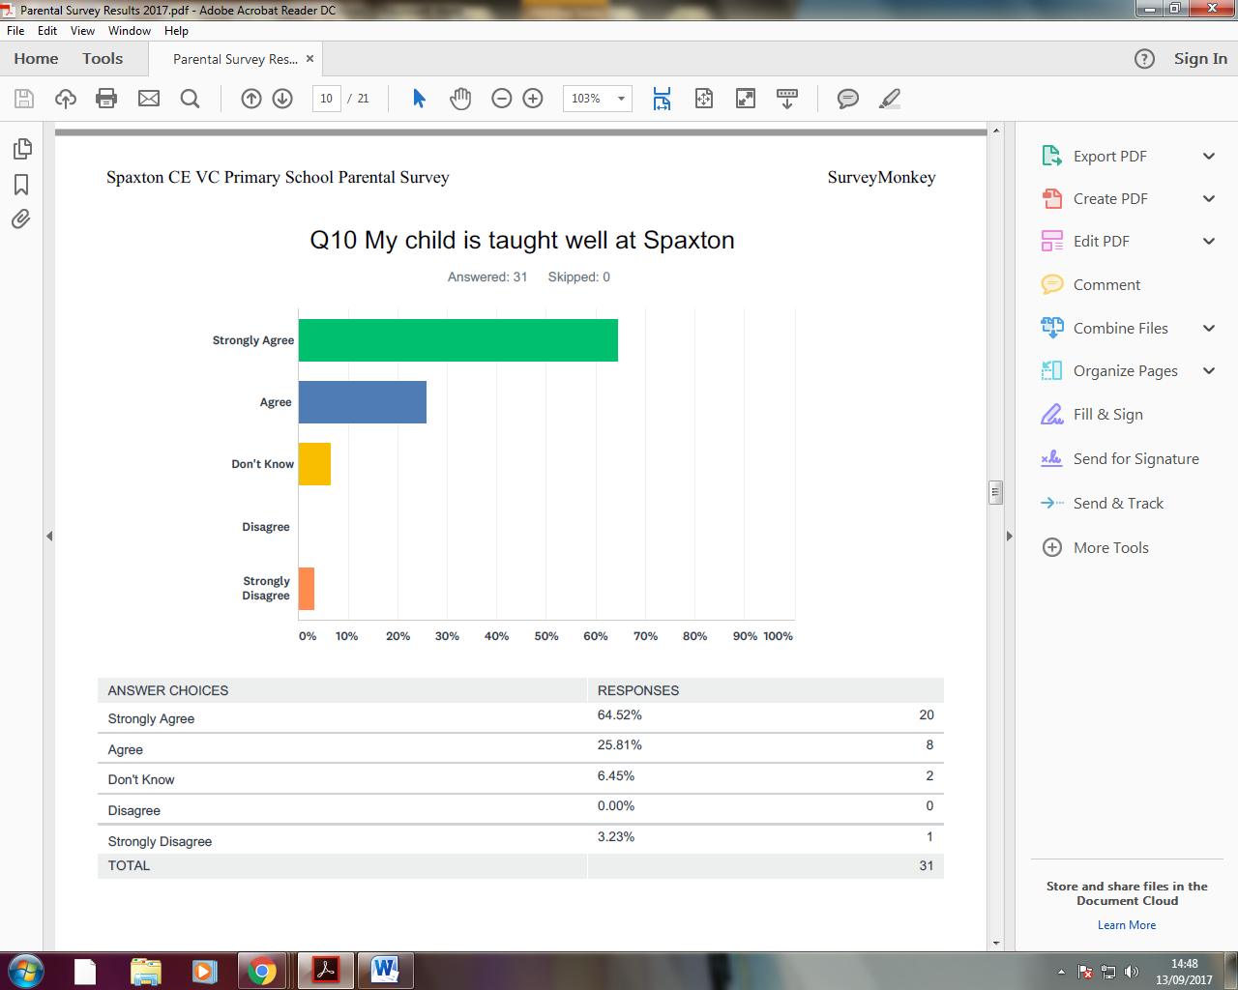
Whilst we are disappointed to see any of our parents unhappy with our teaching, we are pleased that, on the whole, teaching is deemed positive. Whilst we may not always get it right, all of the teachers and staff here at Spaxton consistently go above and beyond to ensure that, as far as possible, our children receive the best possible education. We are proud of our school and all that we offer.

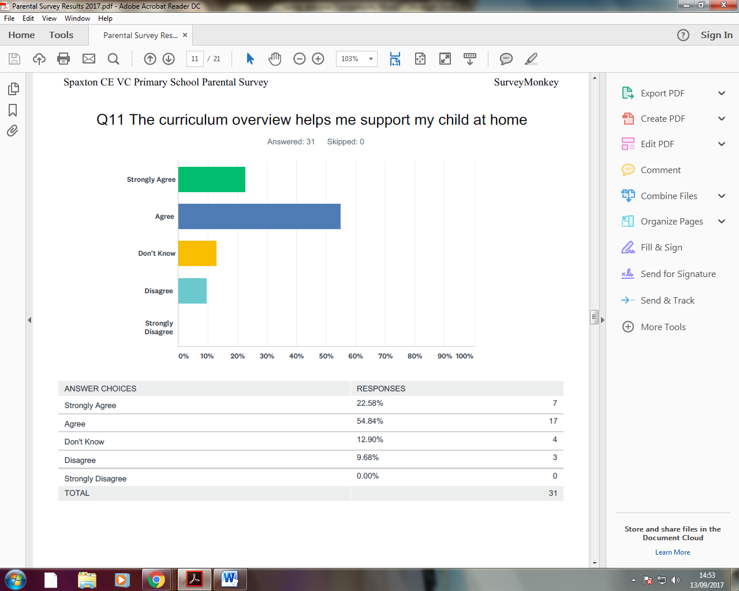

It is important for us to know that our curriculum overviews help you to support your child at home. With over 22% of respondents either disagreeing or not knowing if they help at home, we must have a look, as a staff team, to see what more can done to ensure that the overviews are a helpful document. This will form an action in this year’s SDP.

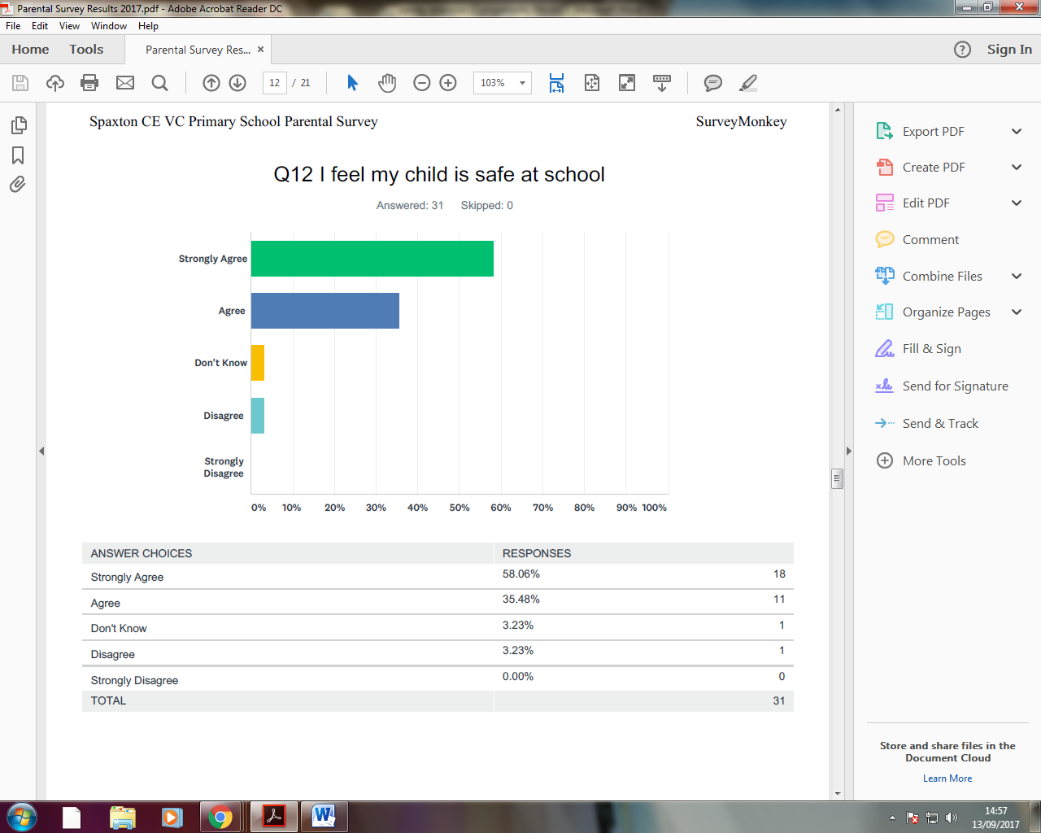
Spaxton School takes safeguarding incredibly seriously. We are constantly making adjustments and tweaks to ensure safety remains paramount. If you feel there is a concern about any child’s safety please do see Mr Blackmore (DSL) or Mr Kelly (Deputy DSL) in his absence.

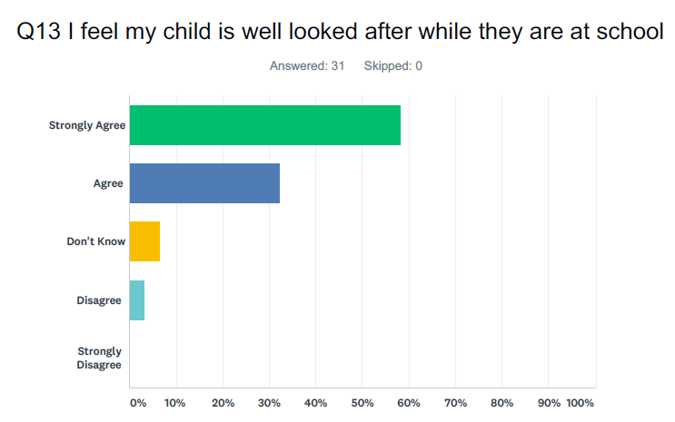
We take great consideration in how we look after your children whilst they are in our care. Again, I can only emphasise that if you are concerned about any issues, here in school, please see your child’s class teacher.
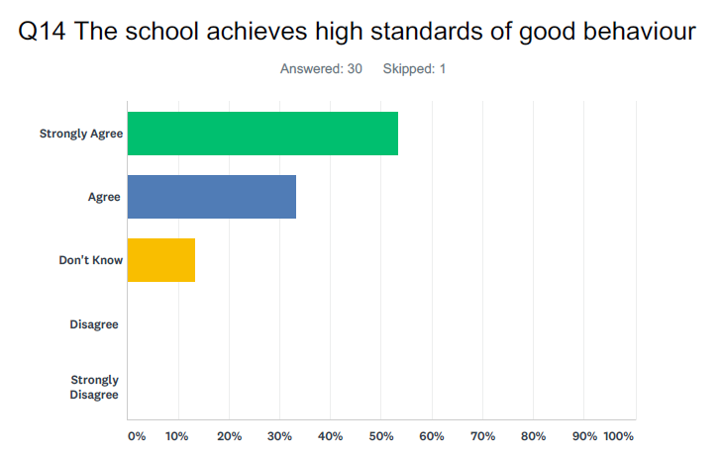
We are very pleased with standard of behaviour in the school and our view seems to be supported by our parents, which is great. Engagement in lessons is key to good behaviour and is indicative of the high standards of teaching and learning in the classrooms. I must also thank the dedication and support of all parents in regards to the upkeep of pupil behaviour.

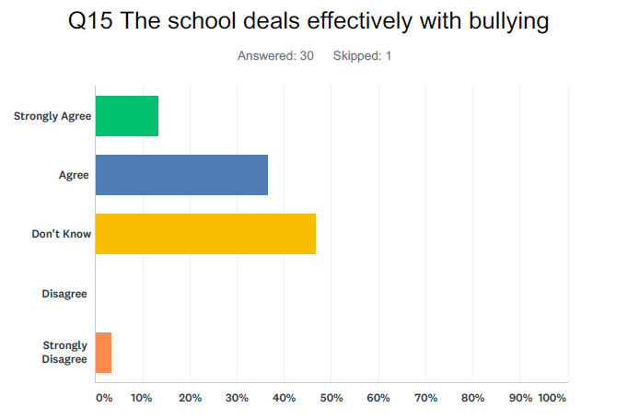
There is often a misunderstanding around the definition of the word ‘bullying’ and that it can often be confused with a short-term issue between two or more children. We take all accusations of bullying seriously and will not tolerate any form of bullying in school. Please come and see the HT or class teachers if you are concerned about any potential bullying.

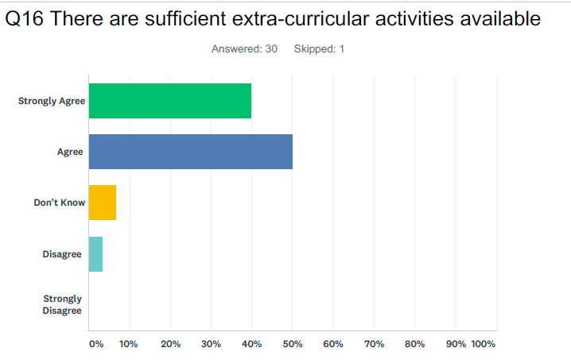
We have worked hard to increase the opportunities for children to learn outside of the classroom. I appreciate that some of the clubs have to be paid for but this is only so that we can increase the amount of sporting opportunities during the year. We never stop looking to see what else can be brought to the school but if you have any ideas of requests, please let us know.
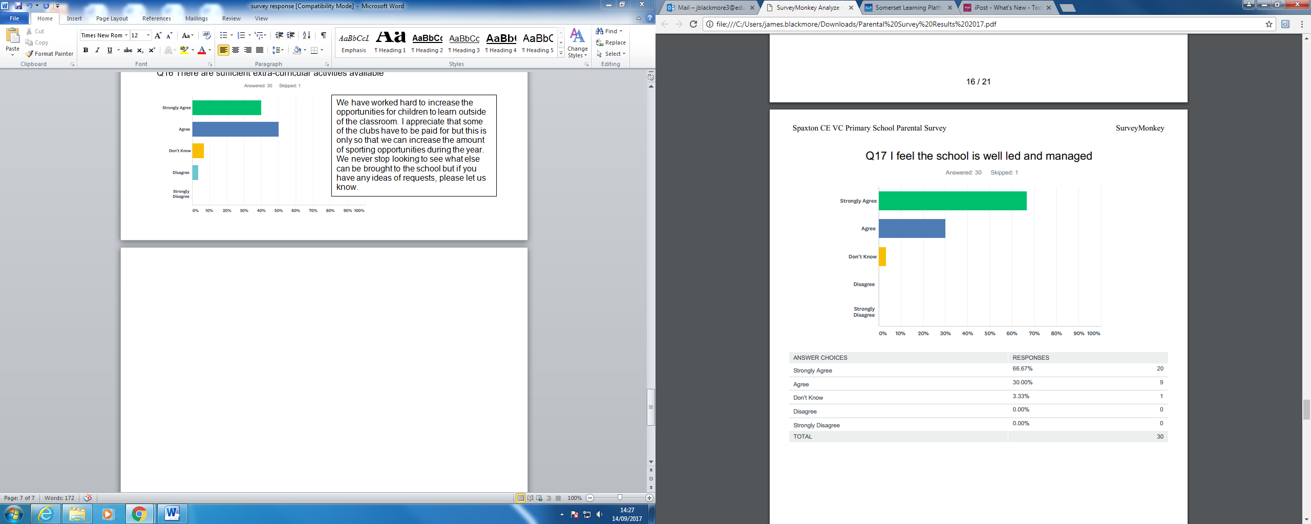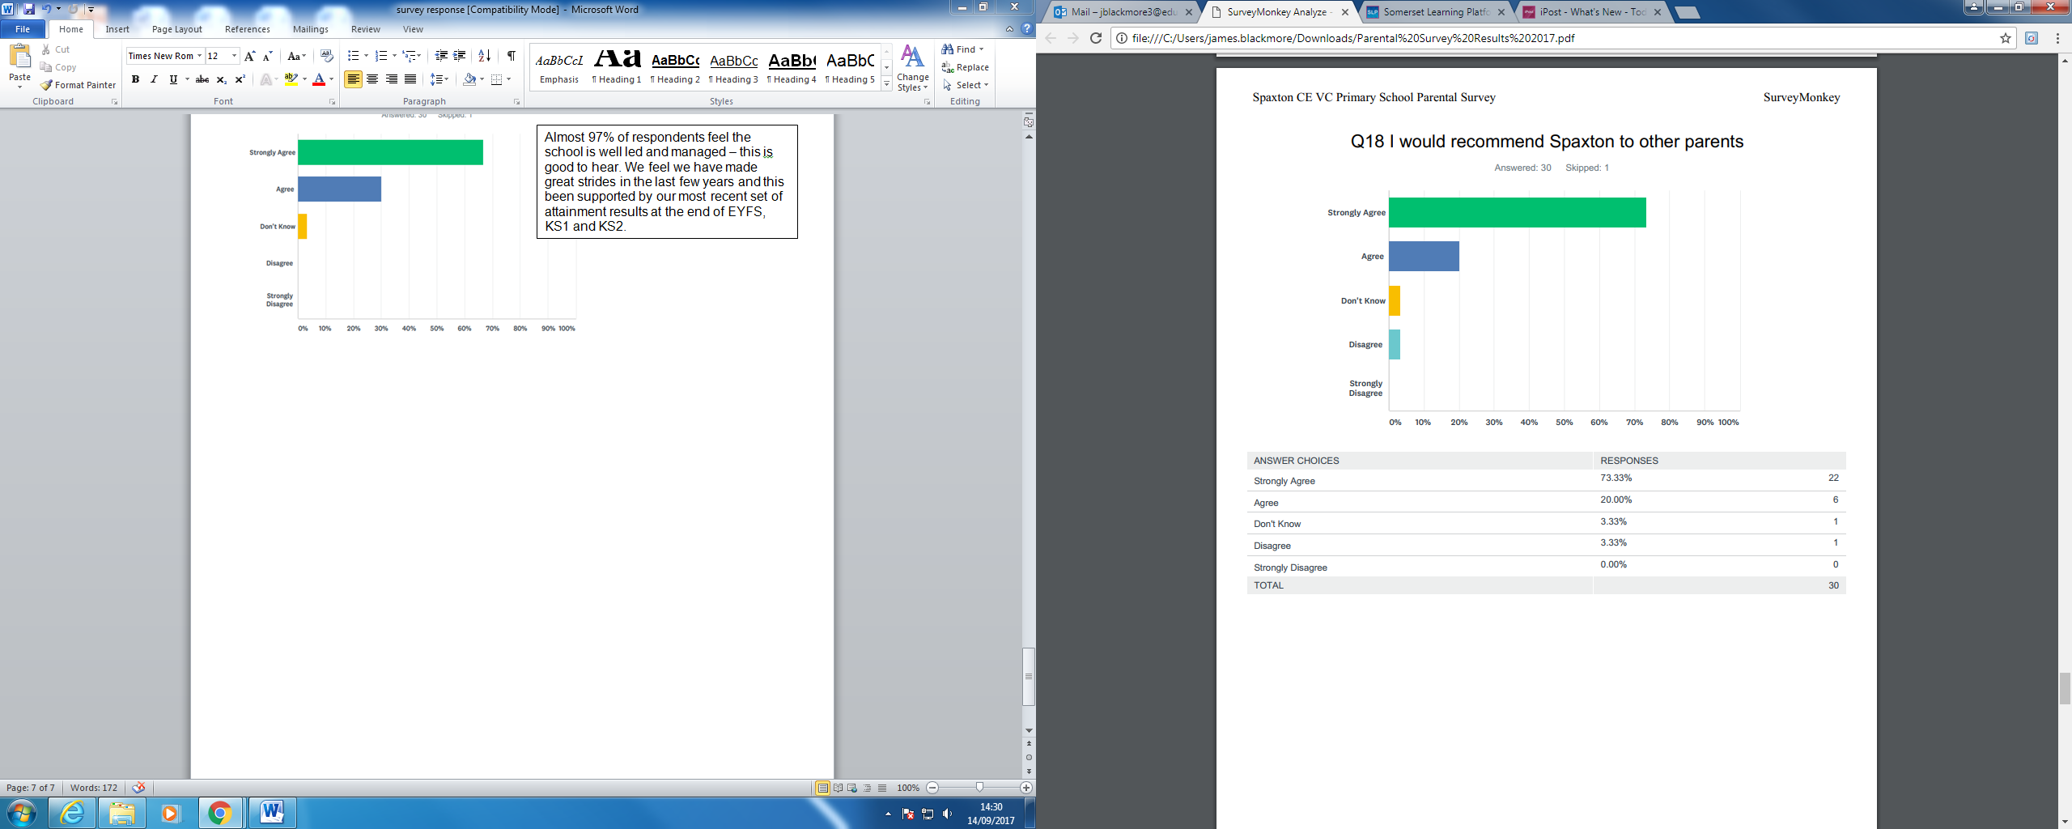
Almost 97% of respondents feel the school is well led and managed – this is good to hear. We feel we have made great strides in the last few years and this been supported by our most recent set of attainment results at the end of EYFS, KS1 and KS2.
In some ways, this is one of the most important questions. We want parents to feel happy and satisfied with what we do, as a school. By recommending Spaxton School to other parents you are advocating and supporting our daily work. We have plans to improve and want to make the school we can all be increasingly proud of.

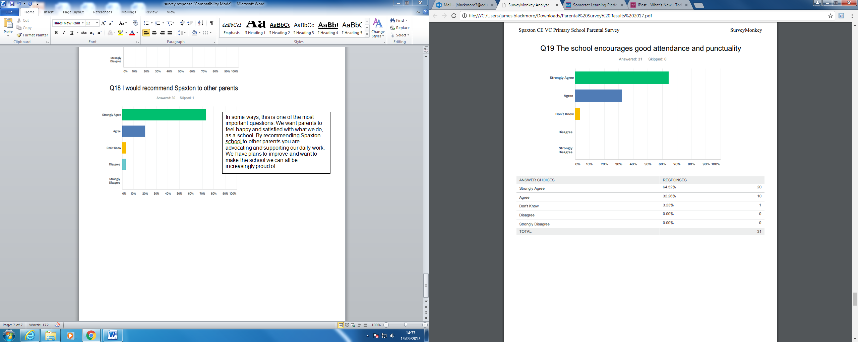
Good attendance is crucial to a good education. Mrs Barber and I meet on a fortnightly basis to analyse attendance and the Education Welfare Officer comes in half termly to check our systems. We have tightened up our processes in the last twelve months and we are pleased that this has been noticed.

