The Bare Necessities









A set of maths games provided by the Wiltshire Primary Maths Team. These can be used at home as a fun way of practising the ‘bare necessities’ in maths – skills that children will need to be confident with in order to succeed in and enjoy maths. We hope that you will have fun playing these games at home with your child! Once learnt the children can also play them with brother/sisters and friends. Enjoy!
If you have any good games of your own we would love to hear about them.

Game 1 – Line Up
Skill to be learnt: To read, write and order whole numbers to at least 1000 and position the on an empty number line.
What you will need: 0 – 1000 blank number line, 0 – 9 die or spinner, coloured pen/pencil for each player.
How to play: Players take it in turns to roll the die 3 times. The first represents hundreds, second is tens, the third is units. Plot the 3 digit number on the number line. First to get 4 in a line without opponent’s number in between wins.
Talk points: On an empty number line your child will need to have an idea about where to position the number that has been generated. You can therefore discuss how to correctly position the number e.g. use markers for multiple of 100 to help.
Extension of this game: To develop tactics in this game allow players to swap digits to change number before plotting.
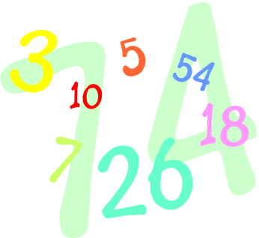

Game 2 – Flashcards
Skill to be learnt: To recall all addition and subtraction facts for pairs of numbers with a total of 20.

What you will need: 0-20 cards.

How to play: Player A shows a card to player B who has to say the number that is needed to add to that number to total 20 (its complement). Time how long it takes for player A to repeat this for all number cards. Swap roles and try and beat each others time.

Talk points: To begin with model how you might work out what the complement is if you do not know this fact off by heart (count up from the
number on the card to 20, use knowledge of pairs to 10 to help etc.)

Extension of this game: Use multiples of 10 number cards to rehearse pairs that total 100.

Game 3 – Snap
Skill to be learnt: To recall all addition and subtraction facts for pairs of numbers with a total of 20.

What you will need: A set of 0-20 cards for each player.
How to play: Deal out the shuffled 0-20 cards and play ‘Snap’. Players say ‘snap’ when the two cards add to 20 (e.g. an 8 is placed on top of a 12).
Talk points: To begin with model how you can anticipate what card you need to be laid next e.g. if an 8 is at the top of the pile you may say ‘I need you to put down a 12 as that makes 20’
Extension of this game: Use multiple of 10 number cards to rehearse number pairs that total 100.



Game 4 – Pairs Game
Skill to be learnt: To recall all addition and subtraction facts for pairs of numbers with a total of 20.

What you will need: 2 sets of 0-20 cards.
How to play: Spread out two packs of 0-20 cards face down on the table. Players take it in turns to reveal 2 cards. If the 2 cards add to make 20 then you can keep the pair, otherwise turn them back over. The player who collects the most pairs is the winner.

Talk points: Use questions such as ‘What is the total?’, ‘What do these two numbers add up to?’ when revealing the cards. As your child becomes more confident in their knowledge of pairs that make 20 you could encourage them to tell you which number they are looking for after they have revealed the first number.

Extension of this game: Use multiple of 10 number cards to rehearse
number pairs that total 100.

Game 5 – Complements
Skill to be learnt: To recall number pairs that total 100.
What you will need: 0 – 9 dice, 1 – 100 grid, counters
How to play: Players take turns to throw the dice to generate a two digit number. They then cover the complement to this number on the 100 square e.g. if you generate a 23 you would cover 77 on the 100 grid. The first player to cover 3 in a line wins.
Talk points: Discuss strategies for working out what the complement to the number you have generated would be. For example if you generate 23 you could encourage your child to work out how many they need to count on to reach the next multiple of 10 ( + 7 to get to 30) and then count in 10’s to 100 (7 tens = 70) so the complement to 23 is 77. Children could use an empty number line to show their workings.
Extension of this game:

Game 6 – Target
Skill to be learnt: To add or subtract mentally a set of one and two-digit numbers.
What you will need: 0 – 9 number cards, timer
How to play: Lay out number cards face down. Choose a target number e.g. 15. Reveal 4 cards. Both players then compete to get as close to the agreed target using each of the digits once and addition or subtraction. The player who is closest to the target scores 2 points, equal closest scores 1 point each. First to 10 points wins.
Talk points: Use informal jottings if children struggle to work entirely mentally. Discuss strategies to help when adding e.g. count on from the largest number, look for any pairs that total 10 first etc.
Extension of this game: Set a time limit for working. Increase the number of cards to use or use larger numbers.



Game 7 – Add or Take
Skill to be learnt: To add or subtract mentally a set of one and two-digit numbers.
What you will need: 1 – 100 grid, 0 – 9 dice, counters
How to play: Players take turns to throw the dice to generate two 2 digit numbers. They then choose to add or subtract the numbers and cover the answer on the grid. (Addition answers are often not on the grid which forces more subtraction!). First to cover 3 in a line wins.
Talk points: Discuss the method you have used to add or subtract. Is there another way to do this? Why did you choose the operation?

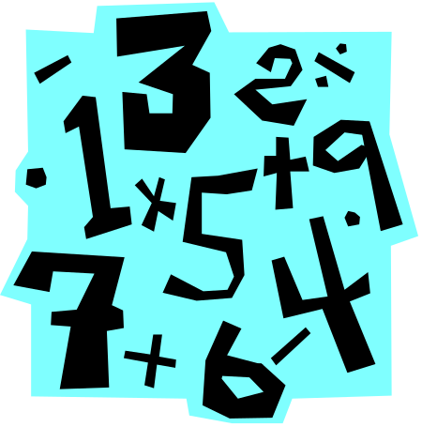

Game 8 – Beat the clock
Skill to be learnt: To know by heart multiplication facts for 2, 3, 4, 5, 6, 7, 8, 9 and 10 times-tables and the related division facts.
What you will need: 2 sets of 0-9 cards
How to play: Shuffle 2 packs of 0 – 9 cards and choose the times table you are working on. Against the clock turn over a card and multiply it by your chosen times table, saying the answer to your partner. Players go through the pack as fast as they can, trying to beat previous times.
Talk points:
Extension of this game: Make number cards which have the answers to a given times table. When shown a card your child can tell you the associated multiplication fact e.g. if shown 36, they may say 6 lots of 6 or 6 x 6.


Game 9 – Remainder 
Skill to be learnt: To know by heart multiplication facts for 2, 3, 4, 5, 6, 7, 8, 9 and 10 times-tables and the related division facts.
What you will need: 1 – 100 grid, dice, counter each
How to play: Place a counter each on 0. Players take turns to throw their dice and move their counter. Players divide the number they land on by 4 and score the remainder (so if you landed on 18 you would score 2 as 18 divided by 4 is 4 remainder 2). The player with the highest score when first player passes 40 wins.
Talk points: When working out the remainder encourage children to use their knowledge of their times tables so for example if you land on 18, ask ‘How many groups of 4 are in 18?’. You could recite the 4 times table to find the fact that is nearest to the number you have landed on.

Extension of this game: Choose other times tables to play the game with.

Game 10 – Flip ‘n’ Roll
Skill to be learnt: To multiply one-digit and two-digit numbers by 10 or 100, and describe the effect.
What you will need: 0 – 9 dice, coin
How to play: Roll the dice to generate a 2 digit number. Then flip the coin. Heads means multiply by 10 and tails means multiply by 100. The first to say the product (answer when 2 numbers are multiplied together) gets a point. The first to 10 points wins the game.
Talk points: Look together at the effect of multiplying by 10 - all digits move one place to the right and a zero becomes a place holder in the units column. Although it may look to the children as though a 0 has been added it should not be described in this way as this does not work for decimals!
Extension of this game: Use 3 or 4 digit numbers to begin with, then move onto decimal numbers. Multiply by 10, 100 and 1000.
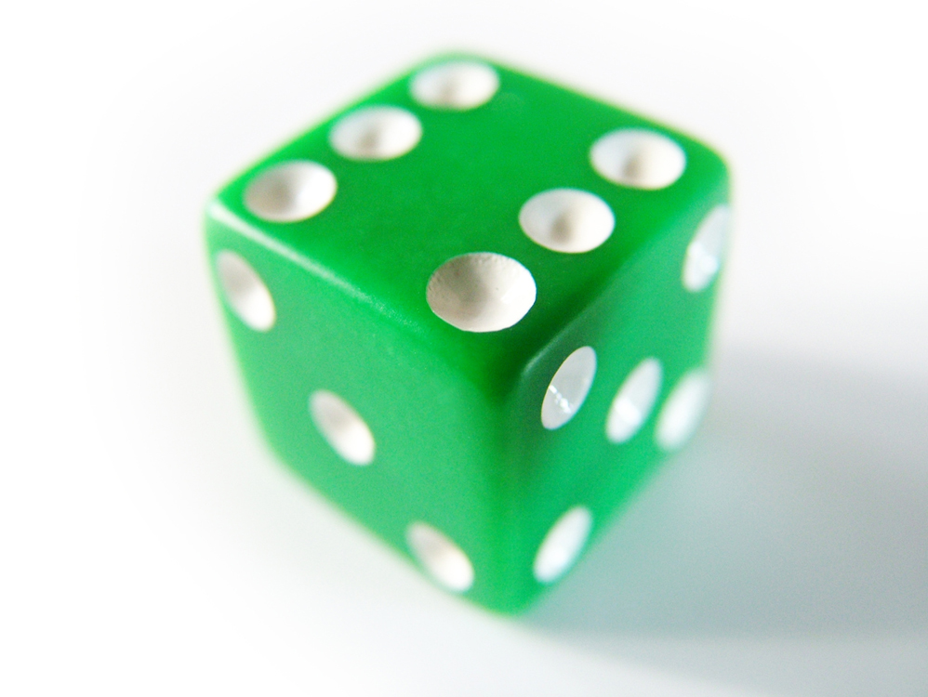
Game 11 – Fishy, fishy fingers
Skill to be learnt: To know by heart multiplication facts for 2, 3, 4, 5, 6, 7, 8, 9 and 10 times-tables and the related division facts.
What you will need: Yourselves!
How to play: Two players face each other and both chant ‘fishy, fishy, fingers (in the same way as you would if playing ‘paper, scissors, stones)’.Both players show a number of fingers to each other. The first player to say the product (total when 2 numbers are multiplied together e.g. the product of 2 and 5 is 10) of the fingers shown scores a point. First player to 10 points wins.
Talk points: Try and think of tricks to help your child remember their times tables e.g. think of x2 as doubling. Encourage children to be thinking of the times tables they might need as they reveal their fingers for example if they know you are going to show 6 fingers have possible facts to the 6 times table in their head ready!

“Fishy, fishy fingers!”

“12!”




Game 12 – Decimal Line up!
Skill to be learnt: To use decimal notation for tenths and hundredths and position on a number line.

What you will need: 0-9 dice, 0-10 blank number line, coloured pencil for each player.

How to play: Players take it in turns to roll the dice to generate a 2 digit number. The first roll represents the units and the second is the tenths e.g. 3.4. Plot the number on the number line. First to get 3 in a line wins.

Talk points: On an empty number line your child will need to have an idea about where to position the number that has been generated. You can therefore discuss how to correctly position the number.

Extension of this game: Extend to 2 decimal places using a 0 – 1 number line.

Game 13 – Make 100
Skill to be learnt: To recall all pairs of numbers which total 100
What you will need: 0 – 100 cards
How to play: Against the timer players reveal cards and have to say the number that would be needed to total 100. How many cards can you reveal in 2 minutes?

Talk points: To help your child work out the complements to make 100 draw comparisons with pairs to 10 e.g. you know that 9 + 1 = 10 so you can use this to help you work out that 90 + 10 = 100. Use strategies such as counting on to the next 10 before counting in tens to 100.

Extension of this game: Reduce the time, how many can you do in a minute?

 Game 14 – Round and divide
Skill to be learnt: To multiply and divide numbers to 1000 by 10 and then 100
What you will need: 0 – 9 dice, 1 – 100 grid, counters
How to play: Players take it in turns to generate a 3 digit number and round it to the nearest 10 e.g. 355 rounded to the nearest 10 is 360. They then divide the result by 10 and cover the answer on the 100 grid (e.g. 360 divided by 10 equals 36 so 36 is covered on the grid). If a number is already covered by your opponents you can replace it. First to 3 in a line wins.
Talk points: Discuss the rules of rounding a 3 digit number to the nearest 10 (if a number has 0,1,2,3,or 4 in the units column you round down, 5 or above you round up).
Extension of this game: Generate 4 digit numbers, round to the nearest 100 and then divide by 100.

 Game 15 – Quick Add
Skill to be learnt: To add or subtract mentally pairs of two digit whole numbers (e.g. 47 + 58, 91 – 35)
What you will need: 0 – 9 digit cards
How to play: Place all cards face down. Players generate a 2 digit number each by revealing 2 cards. The first to add them gets a point. First to 10 points wins.
Talk points: .Discuss strategies used when calculating. Is there a different way? Which strategy is best for these numbers?
Extension of this game: Play Quick Difference where players subtract one number from the other rather than add. These games could also be played using decimal numbers.

Game 16 – Remainder Choice
Skill to be learnt: To know by heart all multiplication facts up to 10 x 10 and the corresponding division facts.
What you will need: Dice, 1 – 100 grid, counters
How to play: Players take it in turns to throw the dice and move along the 1 – 100 grid. Players choose whether to divide the number they land on by 4 or 6. They then score the remainder. So for example if the player lands on 28 they would be better to choose to divide by 6 because this gives a remainder of 4 whereas dividing by 4 will give 0 remainder. The winner is the person who has the highest score when the first player reaches 100.
Talk points: Have available the 4 times table and 6 times table as a reference if your child is unsure of these facts. Discuss together how to work out the remainders and which will give the biggest score.
Extension of this game: Choose other numbers to divide by.

Game 17 – Rounding Target
Skill to be learnt: To explain what each digit represents in numbers with up to 2 decimal places. Round numbers up to 2 decimal places.
What you will need: 0 – 9 cards
How to play: Choose a target number with one decimal place between 1 and 9 e.g. 5.6. Players take it in turns to turn over 3 cards to make a number with 3 decimal places e.g. 4.55. Then round this number to the nearest tenth e.g. 4.6 before finding the difference which in this case would be 1. After 5 goes each the player with the largest total loses.
Talk points: Discuss the rules of rounding decimal numbers which follow the same pattern as when rounding whole numbers (4 or below you round down, 5 or more you round up).
Extension of this game: Increase to numbers with 3 decimal places.



Game 18 – Half or double plot it
Skill to be learnt To find halves and doubles of decimals.
What you will need: 0 – 9 dice, 0 – 20 blank number line
How to play: Players take it in turns to roll the dice to generate units and tenths. Choose whether to halve or double and plot the answer on a 0 – 20 blank number line. The first player to get 4 numbers in a row without opponent’s number in between wins.
Talk points: Discuss the effect of doubling and halving on numbers (doubling the number makes it bigger; halving the number makes it smaller). Emphasise that doubling is the opposite of halving.
Extension of this game: Extend to 3 decimal places.



Game 19 – Chunky
Skill to be learnt To multiply a 2-digit number by a 1-digit number.
What you will need: 0 – 9 dice
How to play: Players take it in turns to roll the dice to generate a three digit number. Decide what the biggest ‘chunk’ of 7 is that can be made e.g. spin 456, the biggest chunk of 7’s that can be made is 420 (60 x 7). Players then score the difference which in this case is 36. The player with the lowest score after 5 turns each wins.
Talk points: To find the biggest chunk use knowledge of 7 times table and place value to find the answer e.g. 6 x 7 = 42 can be used to calculate 60 x 7 = 420.
Extension of this game: Repeat with other times tables.

Game 20 – Noughty noughty
Skill to be learnt To multiply and divide numbers by 10, 100 and 1000
What you will need: 1 – 100 grid, dice showing x10, x100, x1000, +10, +100, +1000, counters
How to play:. Players take it in turns to choose a number on the 1 -100 grid. Throw the dice and perform that operation in their chosen number. If they are correct they can cover that number, if incorrect play moves to the next player. First player to get 4 in a row wins.
Talk points: Discuss the effect of multiplying by 10, 100 or 1000 and adding 10, 100 or 1000 – what appears to happen? For example when multiplying by 10 - all digits move one place to the right and a 0 becomes a place holder in the unit’s column. Although it may look to the children as though a 0 has been added it should not be described this way.
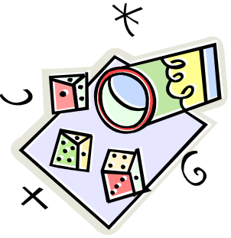

Game 21 – Multiplication Choice
Skill to be learnt To multiply a 2 digit number by a 1 digit number.
What you will need: 0 – 9 dice, 0 – 1000 blank number line, coloured pencil for each player.
How to play: Players take it in turns to spin the spinner 3 times to generate 3 digits. They use these to make a 2 digit and a 1 digit number and multiply them. They plot the answer on a 0 – 1000 number line. The first player to plot 4 numbers without their opponent’s number in between wins.
Talk points: Use knowledge of multiplying single digit number to help when multiplying a 2 digit by a 1 digit number e.g. use knowledge of 6 x 8 = 48 to multiply 6 x 80 = 480. Encourage children to use partitioning when multiplying mentally – see ‘Progression in multiplication stage 1’.
Extension of this game: Extend to 3 decimal places.


