The story of East African Playgrounds
In 2008, Tom Gill and Carla Powell were studying at the University of Leeds. They had both spent time in East Africa working with charities and NGOs, and during their time there had realised that there were three issues that were not only close to their hearts but also that they had the experience, skill sets and drive to tackle. Firstly, there was a huge lack of safe, fun and exciting playgrounds for children to play on. Secondly there was a lack of opportunities for young adults to gain training and employment. There were also far too many volunteer companies charging young volunteers huge sums of money for volunteering projects and actually having a negative impact on the communities they were supposed to be helping.
During the next year Tom and Carla spent time researching play, playgrounds and how to set up and run a successful charity. In 2009 East African Playgrounds was formed, and the first playground in Uganda was built through our first volunteering project. The first year was a huge challenge for Tom and Carla as they both juggled their studies, part-time night shifts and setting up and running the charity. By the end of the first year they had learnt more than they thought possible, had developed a fantastic trustee board for East African Playgrounds in the UK and had a very clear goal for the next 3 years.
Through Tom and Carla's final years of university they developed East African Playgrounds' Uganda Volunteering Project to fund the development of a Ugandan playground building team, a workshop and 19 playgrounds. During this period, East African Playgrounds' building methods and community consultation process were also developed, to ensure that playgrounds were custom designed for each community and the children who would use them.
The journey continued from there, each day the charity growing that bit more.

What we've achieved

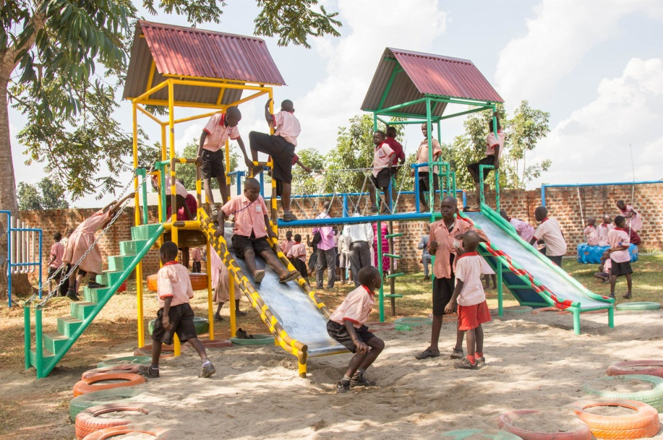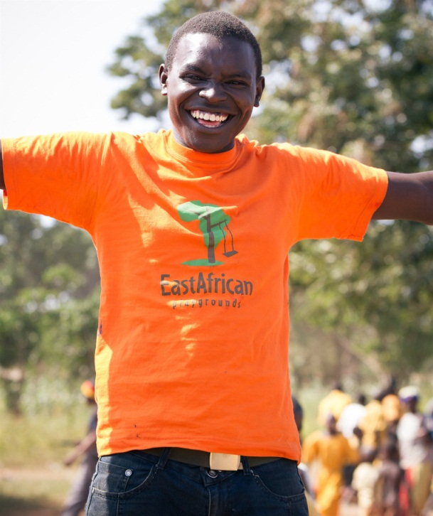

199 Playgrounds installed 45 Ugandan staff trained

45
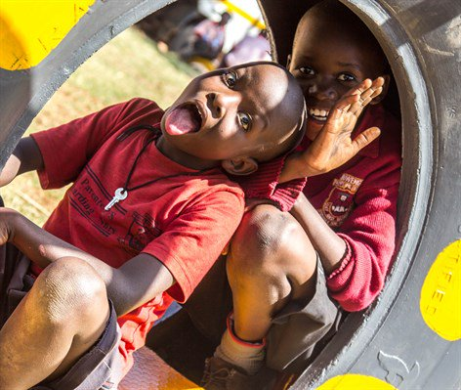8500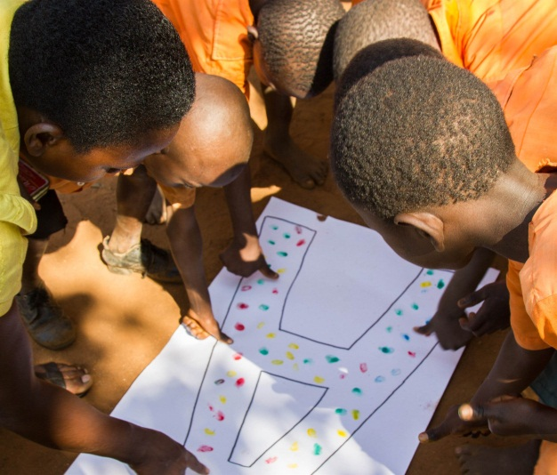

298,500 Children impacted 63 Centres received our

Play Programme

63

East African Playgrounds is a member of and accredited by several networks and organisations, in various areas of our work. Working in partnership with these bodies mean we can demonstrate our effectiveness, credibility and achieve even greater impact.

Duke of Edinburgh's Award
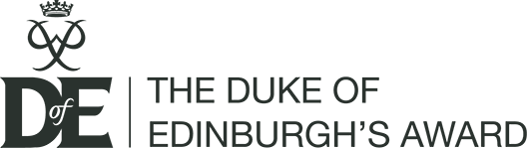
Through our international volunteer projects, East African Playgrounds is an Approved Activity Provider (AAP) for the Duke of Edinburgh's Award. This means our projects meet the required conditions and can count towards the achievement of a DofE Award.

Playground standards
It is important to us that the playgrounds we construct meet the high standards of playgrounds across the world. Therefore, we have taken playground standards from across the world and put together a user-friendly manual to ensure the safe construction of playgrounds.

Global Play Alliance
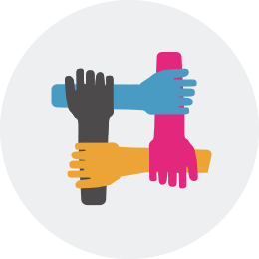
East African Playgrounds is the largest partner in the network of organisations called the Global Play Alliance. This is a network of organisations focused on creating play opportunities for children in communities where these resources do not exist or are in short supply.

HACT assessed
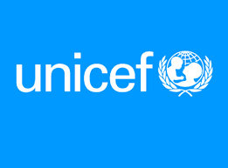
As an implementation partner of UNICEF, we have been HACT (Harmonized Approach to Cash Transfers) assessed this process enables them to increase the overall effectiveness of interventions (focus more on programme needs rather than administrative procedures) and so proves the level of need for audit. Being HACT assessed means East African Playgrounds is eligible to apply for funding that non-HACT accessed organisations cannot.

Fundraising Regulator
East African Playgrounds is registered with the Fundraising Regulator, the body that lays out the standards and regulations for charity fundraising. By being registered with the Fundraising Regulator East African Playgrounds commits to being open, honest and accountable to its donors and the general public, and to adhere to the Code of Fundraising Practice and the 'Fundraising Promise'.

Institute of Fundraising
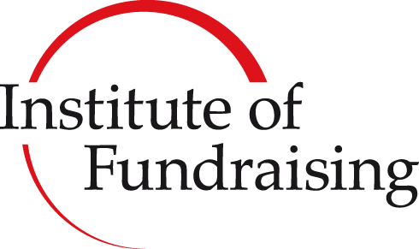
East African Playgrounds is an organisational member of the Institute of Fundraising, the professional body for fundraisers. The Institute of Fundraising's support ensures that our fundraising represents best practice and will help to increase public trust and confidence in the voluntary and community sector.

Play is the universal language of a child.

Play is incredibly important for children’s learning, wellbeing and for healthy brain development – the UN includes the right to play in its Convention on the Rights of the Child, the most complete statement of children’s rights ever produced.

Multiple long-term studies have shown how important play is for the development of children and their long-term outcomes, especially those living in poverty (Gertler et al, 2013; Kellock, 2015; Schweinhart et al, 2005; Walker et al, 2011). Play has been shown to be beneficial for everything from social skills, cognitive abilities and problem solving, to fine motor skills, concentration, communication, imagination, and self-control. It’s been shown that adding play to a child’s life can lead to significantly raised IQs, greater achievement at school and even higher rates of employment and wages in adulthood.

But, in many communities across East Africa, children spend time out of school looking for work or helping with chores at home, rather than playing. Play is often viewed by adults as a waste of time, with little understanding of its importance for children. There are very few play facilities available for children, and those that do exist are often unsafe or poor quality.

When children are in school, large classes and lack of facilities mean that a system of ‘rote’ (repetition-based), ‘one size fits all’ teaching is used by teachers, which means that children are limited in self-expression and creativity. This is restricting and frustrating for children as these are an important part of their learning. A lack of funding means that most schools do not have play equipment, and play is not seen as a priority by teachers.

Jasmine's Fundraising for Volunteering in Uganda!

For 3 weeks in the summer of 2018, I will be trekking through Uganda, helping to build and restore safe playgrounds for children. The United Nations have listed play as a human right for all children, and this opportunity will be able to give them this chance to do something we take for granted. Something as simple as a playground can help improve a child's life as well as will help them cultivate their creativity and develop physical and social skills, problem solving abilities, and much more!
I will also be trekking to see the critically endangered Silverback Gorillas, and a portion of the money fundraised for the permit to see them will go towards conservation efforts and pays the wages of guides and guards protecting them.
This trip will give me the chance to help a community directly, and give these children the childhood they deserve. All donations towards this cause will really be greatly appreciated, even the smallest help can make a huge difference.

Thanks!
Jasmine Harris

